
COMSATS University Islamabad, Sahiwal Campus

Taste Clip: Capturing Product Experiences in Motion

A project presented to
COMSATS Institute of Information Technology, Islamabad

In partial fulfilment
of the requirements for the degree of

Bachelor of Science in Computer Science (2021-2025)

By

Muhammad Mutayyab Hussain CIIT/FA21-BCS-056/SWL
Hamza Nasir CIIT/FA21-BCS-087/SWL
Muhammad Hassan Abbas Jalvi CIIT/FA21-BCS-099/SWL


COMSATS University Islamabad, Sahiwal Campus

Taste Clip: Capturing Product Experiences in Motion

By

Muhammad Mutayyab Hussain CIIT/FA21-BCS-056/SWL
Hamza Nasir CIIT/FA21-BCS-087/SWL
Muhammad Hassan Abbas Jalvi CIIT/FA21-BCS-099/SWL

Supervisor
Mr. Arslan Sarwar

Bachelor of Science in Computer Science (2021-2025)

The candidate confirms that the work submitted is their own and appropriate credit has been given where reference has been made to the work of others.
Declaration
We hereby declare that this software, neither whole nor as a part, has been copied from any source. It is further declared that we have developed this software and the accompanied report entirely based on our personal efforts. If any part of this project is proved to be copied from any source or found to be a reproduction of some other work. We will stand by the consequences. No Portion of the work presented has been submitted to any application for any other degree or qualification of this or any other university or institute of learning.

Muhammad Mutayyab Hamza Nasir Muhammad Hassan
Hussain Abbas Jalvi

Certificate of Approval
It is to certify that the final year project of BS (CS) “TasteClip” was developed by Muhammad Mutayyab Hussain (CIIT/FA21-BCS-056/SWL), Hamza Nasir (CIIT/FA21-BCS-087/SWL) and Muhammad Hassan Abbas Jalvi (CIIT/FA21-BCS-099/SWL) under the supervision of “Mr. Arslan Sarwar” and co-supervisor “Mr. Ahmad Shaf” and that in their opinion, it is fully adequate, in scope and quality for the degree of Bachelor of Science in Computer Sciences.

Supervisor
Mr. Arslan Sarwar
Lecturer
Department of Computer Science
COMSATS University Islamabad, Sahiwal Campus

External Examiner
Dr. Muhammad Umar Draz
Lecturer
Department of Computer Science
University of Sahiwal

Head of Department
Dr. Zafar Iqbal Roy
Assistant Professor
Department of Computer Science
COMSATS University Islamabad, Sahiwal Campus
Executive Summary
TasteClip is an innovative mobile application designed to transform how people share and explore restaurant experiences. In today’s world, customers want more than just text-based reviews, they want immersive, visual insights that help them make confident dining choices. TasteClip addresses this need by offering a dedicated platform where users can upload dynamic video reviews of their dining experiences, providing an authentic and engaging way to evaluate food quality, ambience, service, and overall satisfaction.
The application supports user registration and login, allowing individuals to create personalized profiles. Users can watch video reviews from others, upload their own experiences, and earn rewards through a coin-based system that encourages active participation. These coins can be used for app privileges, enhancing engagement and retention. The app also includes features like viewing restaurant offers, accessing contact information, using maps for directions, and interacting with community feedback.
For restaurant managers, TasteClip provides a powerful set of tools for digital marketing and customer engagement. They can create and manage promotional events, discounts, and content posts to attract more visitors. Additionally, managers can watch reviews submitted about their establishments, report inappropriate content, and respond to customer feedback. A built-in approval system ensures quality and relevance in published content, maintaining trust across the platform.
TasteClip is built using Flutter for cross-platform compatibility and utilizes Firebase as its backend, ensuring real-time data management, authentication, and storage. The user interface is designed to be clean, intuitive, and mobile-friendly, catering to both consumers and restaurant businesses.
By blending authentic user-generated video content with interactive tools for both customers and restaurant managers, TasteClip offers a modern, unified solution to the gaps in current restaurant review platforms. It redefines how people discover dining spots and how businesses receive meaningful, actionable feedback, ultimately contributing to a more transparent and connected food culture.

Acknowledgement
All praise is to Almighty Allah, who bestowed upon us a minute portion of His boundless knowledge by which we were able to accomplish this challenging task.
We are greatly indebted to our project supervisor, “Mr. Arslan Sarwar” and our co-supervisor, “Mr. Ahmad Shaf”. Without their personal supervision, advice and valuable guidance, completion of this project would have been doubtful. We are deeply indebted to them for their encouragement and continual help during this work.
And we are also thankful to our parents and family who have been a constant source of encouragement for us and brought us the values of honesty & hard work.

Muhammad Mutayyab Hamza Nasir Muhammad Hassan
Hussain Abbas Jalvi

Abbreviations
API | Application Programming Interface
CS | Computer Science
SRS | Software Requirement Specification
SDD | Software Design Description
GUI | Graphical User Interface
AG | Agile Model
IDEs | Integrated development environments
UI | User Interface
UX | User Experience
DB | Database
CRUD | Create, Read, Update, Delete
API | Application Programming Interface
CS | Computer Science
SRS | Software Requirements Specification
SDD | Software Design Description
GUI | Graphical User Interface
AG | Agile Model
IDEs | Integrated Development Environments

Table of Contents
1 Introduction 2
1.1 Brief Overview 3
1.2 Relevance to Course Modules 3
1.3 Project Background 5
1.4 Analysis from Literature Review (in the context of the project) 6
1.5 Methodology and Software Lifecycle for This Project 8
1.5.1 Rationale behind Selected Methodology 9
2 Problem Definition 13
2.1 Problem Statement 13
2.2 Deliverable and Development Requirements 14
2.2.1 Deliverables 14
2.2.2 Development Requirements 15
2.3 Current System 17
2.3.1 Key Limitations of Existing Systems 17
3 Requirement Analysis 20
3.1 Use Case Diagram 20
3.2 Use Case Description 21
3.3 Functional Requirements 32
3.3.1 User Registration and Authentication 32
3.3.2 Review Submission 33
3.3.3 Review Moderation 33
3.3.4 Restaurant Profile Management 34
3.3.5 Search and Discovery 35
3.4 Non-Functional Requirements 35
3.4.1 Usability 35
3.4.2 Performance 36
3.4.3 Security 36
3.4.4 Portability 37
3.4.5 Reliability 37
3.4.6 Maintainability 37
3.4.7 Scalability 38
4 Design and Architecture 40
4.1 System Architecture 40
4.2 Process Flow Representation 40
4.3 Sequence Diagram 41
4.4 Class Diagram 42
5 Implementation 45
5. Review and Content Management Module: 46
5.1 Algorithm 47
5.2 User Interface 48
5.2.1 Consumer Interface 48
5.2.2 Restaurant Manager Interface 53
5.2.3 Admin Interface 57
6 Testing and Evaluation 62
6.1 Manual Testing 62
6.1.1 Unit Testing 63
6.1.2 Functional Testing 63
6.1.3 Integration Testing 64
6.2 Automated Testing 65
7 Conclusion and Future Work 67
7.1 Conclusion 67
7.1.1 Technical Architecture: 67
7.1.2 Technical Architecture: 68
7.1.3 Scope for Further Development: 68
7.2 Future Work 68
7.2.1 AI-Powered Restaurant Recommendations 68
7.2.2 Advanced Reward Mechanisms and Gamification 69
7.2.3 Offline Video Uploading & Syncing 69
7.2.4 In-App Chat and Messaging 69
7.2.5 Expanded Admin Analytics Dashboard: 69
7.2.6 Restaurant Performance Insights: 70
7.2.7 Multi-language Support 70
7.2.8 Social Media Integration 70
7.2.9 Web-Based Application 71
7.2.10 Geolocation-Based Promotions 71
7.2.11 Augmented Reality (AR) Restaurant Previews 71
References 72

List of Figures
Figure 3.1 Use Case Diagram 21
Figure 4.1 Architecture Diagram 40
Figure 4.2 Process Flow Diagram 41
Figure 4.3 Sequence Diagram 42
Figure 4.4 Class Diagram 43
Figure 5.1 Role Selection Screen 48
Figure 5.2 Registration Screen 49
Figure 5.3 Login Screen 49
Figure 5.4 Home Screen 50
Figure 5.5 Feedback Type Selection Screen 50
Figure 5.6 Restaurant Selection Screen 51
Figure 5.7 Restaurant Branch Selection Screen 51
Figure 5.8 Upload Review Screen 52
Figure 5.9 Review Watch Screen 52
Figure 5.10 Find Best Bite Screen 53
Figure 5.11 Channel Registration Screen 53
Figure 5.12 Manager Login Screen 54
Figure 5.13 Waiting for Approval Screen 54
Figure 5.14 Channel (Manager Dashboard) 55
Figure 5.15 Feedback Summary Screen 55
Figure 5.16 Feedback Report Screen 56
Figure 5.17 Create Voucher Screen 56
Figure 5.18 Create Event Screen 57
Figure 5.19 Admin Authentication Screen 57
Figure 5.20 Admin Dashboard Screen 58
Figure 5.21 Restaurant Management Screen 58
Figure 5.22 Reported Feedback Management Screen 59
Figure 5.23 User Management Screen 59
Figure 5.24 Restaurant Profile Screen 60

List of Tables
Table 3.1 Use Case: Register 22
Table 3.2 Use Case: Login 22
Table 3.3 Use Case: Logout 23
Table 3.4 Use Case: Registration Request 23
Table 3.5 Use Case: Like 24
Table 3.6 Use Case: Comment 24
Table 3.7 Use Case: Share 25
Table 3.8 Use Case: Post Announcements 25
Table 3.9 Use Case: Create polls 26
Table 3.10 Use Case: Post Events 27
Table 3.11 Use Case: View Reviews 27
Table 3.12 Use Case: Post Reviews 28
Table 3.13 Use Case: Find Best Bite 28
Table 3.14 Use Case: Manage User Reviews 29
Table 3.15 Use Case: Approve Restaurant Registration Request 30
Table 3.16 Use Case: Rewards 31
Table 3.17 Functional Requirement: User Registration and Authentication 32
Table 3.18 Functional Requirement: Review Submission 33
Table 3.19 Functional Requirement: Review Moderation 34
Table 3.20 Functional Requirement: Restaurant Profile Management 34
Table 3.21 Functional Requirement: Search and Discovery 35
Table 6.1 Manual Testing 62
Table 6.2 Unit Testing 63
Table 6.3 Functional Testing 64
Table 6.4 Integration Testing 64

Chapter 1
Introduction

Introduction
In today’s technology-driven society, the way people interact with food services has evolved significantly. The traditional methods of relying on word-of-mouth or static images in brochures have been replaced by interactive digital platforms. Consumers now prefer to base their dining decisions on real-time experiences shared online. Social proof, particularly in the form of reviews, has become an essential factor in influencing customer choices. The reliability and authenticity of these reviews, however, continue to pose a challenge.
While platforms like Google Reviews, Yelp, and TripAdvisor have facilitated easy access to customer opinions, they are largely limited to text-based feedback. These forms of reviews often lack emotional depth and visual context, making it difficult to judge intangible elements like ambiance or customer service. Moreover, the increasing incidents of fake reviews and paid promotions have eroded the trust users place in these systems. Static images may help to an extent, but they still fail to convey aspects like sound, tone, atmosphere, or staff demeanor.
The surge in popularity of video-sharing platforms like TikTok, YouTube Shorts, and Instagram Reels indicates a significant shift in how users consume content. These platforms show that people gravitate towards quick, immersive, and visually rich media. It is evident that the modern user demands experiences that are not only informative but also engaging. This cultural shift calls for a specialized application that merges the utility of reviews with the immersive potential of video.
To address these shortcomings, TasteClip emerges as a transformative solution. It is a mobile application designed to bridge the communication gap between diners and restaurants through short-form video reviews. By enabling users to share 30–60 second clips of their dining experiences, TasteClip adds authenticity, transparency, and entertainment to the feedback process. This visual storytelling helps others visualize the restaurant's offerings before making a decision, bringing the digital dining experience closer to reality.
What sets TasteClip apart is its interactive ecosystem. It goes beyond video uploads by incorporating gamified features like coin-based rewards, loyalty recognition, and review challenges that drive community participation. Additionally, it empowers restaurant owners with tools to create promotions, monitor reviews, interact with customers, and analyze feedback, all within a single platform.
TasteClip offers a win-win model where users are rewarded for honest engagement, and restaurant managers gain valuable customer insights and promotional exposure. In doing so, the platform not only enhances customer experience but also supports the food industry in adapting to evolving consumer expectations.

Brief Overview
TasteClip is a cross-platform mobile application developed using Flutter for the frontend and Firebase as the backend service. It reimagines food discovery and restaurant interaction by allowing users to upload, watch, and engage with short video reviews. The platform integrates social interactivity with utility, combining entertainment with purpose.
From the user perspective, TasteClip offers intuitive navigation through various features:
- Video Reviews:
Users can shoot, edit, and post short videos showcasing their food, environment, and service experience.
- Reward System:
Active users earn digital coins based on their review engagement and contributions, which can later be redeemed for benefits.
- Offers and Events:
Restaurants publish limited-time offers or event announcements as interactive cards visible to users.
- Best Bite Algorithm:
An AI-driven recommendation engine that learns from user preferences to suggest the best dining options nearby.
- Google Maps Integration:
Users can locate nearby restaurants and plan visits using real-time map services.
On the business side, restaurant managers access a dedicated interface with tools to:
- Manage restaurant profiles, menus, and operational details.
- Publish events, discount cards, and promotional content.
- Monitor and approve reviews posted by users before they are made public.
- Transfer coins to selected customers as a form of recognition or reward.
- Receive instant notifications and respond to reviews.
Admins maintain platform health through content moderation, user flagging, and analytics, ensuring a clean, fair, and safe environment.
By combining functionality with user-centric design, TasteClip sets itself apart as more than just a review platform. It’s a digital food community focused on meaningful engagement and mutual benefit between customers and restaurants.

Relevance to Course Modules
TasteClip’s development is deeply rooted in concepts and practices acquired through the Bachelor of Science in Computer Science program. Below is an expanded breakdown of how various course modules were applied:
- Software Engineering Concepts:
Employed for systematic requirement gathering, modelling user stories, sprint planning, and risk management. Agile Scrum practices were followed to ensure modular and iterative development, improving both velocity and stakeholder feedback.
- Software Design Methodologies:
Used in designing modular layers of the application — including the frontend (Flutter), backend (Firebase Firestore), middleware logic (GetX), and integration modules (Maps, AI, storage).
- Database Systems:
Firebase Realtime Database and Firestore were utilized for scalable data management. User data, video metadata, reward logs, and notification records are stored in well-structured collections to optimize performance.
- Human-Computer Interaction (HCI):
Ensured intuitive design by performing early mockup testing and adopting modern UX principles like gesture navigation, minimalism, and visual feedback. Tools like Figma helped in wireframing user flows.
- Mobile Application Development:
Flutter, an open-source UI toolkit, was selected to develop cross-platform mobile apps for Android and iOS. Dart was used for programming, ensuring fast development cycles and consistent UI performance.
- Web Technologies:
The administrative panel, enabling admin and restaurant management, was developed using Laravel with a responsive UI for easy browser access.
- Artificial Intelligence:
AI was integrated in two ways:
- Find Best Bite:
A recommendation model using user behaviour data to suggest restaurants.
- Content Moderation:
Machine learning-based image and text classifiers to assist admins in detecting inappropriate content.
These modules not only shaped the technical foundation of the app but also facilitated real-world application of academic knowledge in project planning, development, testing, and deployment.

Project Background
The concept behind TasteClip originated from a deep analysis of the shortcomings prevalent in the current digital food and dining ecosystem. With the surge of digital transformation across industries, the food-tech sector has experienced significant growth. Yet it continues to rely heavily on outdated, text-heavy review systems that fail to capture the full dining experience. While platforms like Google Reviews, Zomato, and TripAdvisor provide basic rating and feedback options, they often do not align with the modern user's expectations for immersive, trustworthy, and engaging content.
A critical turning point in conceptualizing TasteClip was the shift in consumer behavior towards video-centric content consumption. Social media platforms such as TikTok, Instagram Reels, and YouTube Shorts have proven the power of short-form video to influence opinions, build communities, and shape purchase decisions. In the food industry specifically, users are increasingly turning to video-based platforms for inspiration, comparisons, and authentic experiences. This change inspired the idea of embedding short-form video content as the core format for restaurant reviews, transforming feedback from static text into dynamic storytelling.
Another major insight driving the project was the lack of genuine connection between restaurants and their patrons. Traditional review platforms often act as unidirectional channels where restaurants have minimal control or engagement options, and feedback is frequently delayed, manipulated, or unverified. TasteClip introduces a real-time, interactive space where restaurant managers can directly view, respond to, and even reward meaningful customer feedback, thereby closing the loop between service provider and consumer.
The project was also born out of the need to tackle review fraud and authenticity issues. Many platforms suffer from fake or incentivized reviews that distort restaurant reputations. To address this, TasteClip integrates receipt-based validation, video uploads with metadata, and AI moderation to ensure the credibility and origin of each review. This not only builds trust among users but also provides restaurant owners with reliable, actionable insights.
Moreover, the addition of a coin-based gamification model serves as both a motivator and quality control mechanism. Users are encouraged to share honest, helpful feedback in exchange for virtual rewards, which can be redeemed or acknowledged within the system. This approach increases user participation and loyalty while maintaining a high standard of content.
The vision for TasteClip was further solidified through qualitative research, including interviews and focus group discussions with food enthusiasts, bloggers, restaurant managers, and frequent diners. Participants consistently expressed frustration with the limitations of current review systems and showed enthusiasm for a visually driven, authentic, and rewarding feedback platform. Their input played a vital role in shaping TasteClip’s feature set, user interface, and engagement mechanisms.
In essence, TasteClip was designed to serve not only as a review platform but as a collaborative, trust-based ecosystem where food lovers, content creators, and business owners can connect in meaningful ways. It leverages the emotional power of video, the transparency of blockchain-like verification logic (via receipts), and the excitement of gamification to redefine how dining experiences are shared and improved.

Analysis from Literature Review (in the context of the project)
The development of TasteClip is grounded not only in practical observations and stakeholder interviews but also in extensive analysis of academic literature, industry research, and real-world applications within the food-tech and mobile feedback domains. This literature review provided both validation of the proposed idea and insights into how it can surpass the limitations of existing platforms. The following are critical findings from the review and their contextual relevance to the project.
- Trust Deficit in Text-Based Reviews:
Multiple scholarly sources and market analyses confirm the rising concern over the authenticity of online reviews. According to a 2021 study by the World Economic Forum, up to 20–30% of online reviews are estimated to be fabricated or manipulated, often posted by bots or incentivized users. This creates a trust deficit, particularly in sectors where customer experiences are highly subjective, such as dining. TasteClip directly mitigates this issue by introducing receipt-based validation, metadata tagging, and admin moderation, which collectively enhance trustworthiness and reduce the scope for false feedback.
- Preference for Short Video Content:
With the rise of platforms like TikTok, YouTube Shorts, and Instagram Reels, video has become the preferred medium for content consumption. Research by Cisco predicts that 82% of all internet traffic will be video by 2025. Additionally, studies show that short-form videos have a 60% higher user engagement rate compared to static media. TasteClip aligns with this trend by enabling users to record short, authentic, in-app video reviews, offering an immersive experience that text simply cannot replicate.
- Low User Engagement in Traditional Apps:
Existing platforms often struggle to retain active user engagement. Studies reveal that over 70% of app users remain passive consumers rather than active contributors. TasteClip addresses this challenge by gamifying the feedback loop, awarding users with coins for verified contributions, and showcasing top reviewers. This creates a reward-driven environment that encourages ongoing interaction while ensuring quality through moderation pipelines.
- Lack of Restaurant-Centric Features:
Existing platforms often struggle to retain active user engagement. Studies reveal that over 70% of app users remain passive consumers rather than active contributors. TasteClip addresses this challenge by gamifying the feedback loop, awarding users with coins for verified contributions, and showcasing top reviewers. This creates a reward-driven environment that encourages ongoing interaction while ensuring quality through moderation pipelines.
- Technology Trends:
While users are often the primary focus in most review platforms, restaurant owners are left with limited tools for engagement, analysis, or corrective action. TasteClip recognizes this gap and introduces a Restaurant Manager Dashboard, featuring real-time review notifications, approval mechanisms, performance analytics, and customer engagement tools (e.g., coin transfer, event promotions). This two-way feedback loop empowers businesses to respond constructively and improve service based on actionable insights.
- Emerging Technology Trends:
The project aligns with modern software engineering best practices and technology stacks, leveraging Flutter for cross-platform development, Firebase for real-time data and backend services, and Laravel for secure, scalable admin operations. Literature supports the adoption of these tools due to their agility, cost-efficiency, and robustness, especially in startups and MVP-stage applications. Additionally, the integration of AI for review moderation and OCR for receipt validation reflects current trends in intelligent automation and trustworthy data processing.
- Bridging Theoretical Gaps with Applied Innovation:
The synthesis of literature shows a gap between consumer expectations and the actual functionalities provided by current platforms. TasteClip not only fills this void but also introduces a hybrid solution that integrates review authenticity, real-time user engagement, and business empowerment; making it both a theoretically sound and practically viable product.
This comprehensive review underscores that TasteClip is not only innovative but also timely. It answers real-world needs with practical features, bridging theoretical gaps with applied solutions.

Methodology and Software Lifecycle for This Project
To ensure that the development of TasteClip proceeded in a structured, scalable, and user-focused manner, the Agile Scrum methodology was adopted. This choice was influenced by the project's evolving requirements, the need for regular stakeholder feedback, and the necessity for iterative improvement. The Scrum approach facilitated continuous collaboration, early testing, and flexible adaptation to challenges.
Given the complex and feature-rich nature of TasteClip, which includes multiple user roles (consumer, manager, admin), video handling, real-time features, and AI integration; traditional models like Waterfall or V-model were deemed rigid and unsuitable. Agile’s flexibility, modular sprint cycles, and user story-based planning allowed the team to iteratively build, test, and refine the product without being locked into fixed specifications from the start.
- Product Backlog Creation:
The project began with a detailed requirement gathering phase, where essential features like authentication, video upload, receipt validation, reward management, and restaurant profile management were documented. These were translated into user stories and compiled into a structured product backlog categorized by priority and complexity.
- Sprint Planning and Task Breakdown:
The development was organized into bi-weekly sprints. Each sprint focused on a set of core tasks, such as building the review upload module, integrating Firebase authentication, or implementing the admin dashboard. Clear sprint goals were set along with deliverables, assigned responsibilities, and expected timelines.
- Daily Stand-ups:
To maintain momentum and accountability, the development team conducted daily stand-up meetings. These brief sessions helped identify bottlenecks, track progress, and align the team on short-term objectives. This also enabled proactive problem-solving in case of technical dependencies or blockers.
- Sprint Review and Retrospective:
At the end of each sprint, a sprint review meeting was held where newly developed features were demonstrated using emulators or test devices. Stakeholders, including potential users and advisors, were invited to provide feedback. A retrospective session followed each review to analyze what went well, what could be improved, and how to optimize the next sprint cycle.
- Incremental Builds:
TasteClip's build strategy involved frequent incremental releases. Each functional module—such as login, reward redemption, or restaurant profile update was developed and tested individually before being integrated. This ensured faster validation, early bug detection, and smoother integration with Firebase and Laravel components.
This methodology ensured steady progress, early bug detection, and adaptable planning which is vital for an app requiring both frontend elegance and backend stability.

Rationale behind Selected Methodology
Choosing the most appropriate software development methodology is one of the most critical decisions in any software project. For the development of TasteClip, the project team explored multiple options including the Waterfall model, V-model, Spiral model, and Rapid Application Development (RAD). After thorough evaluation, the Agile Scrum methodology was selected due to its flexibility, adaptability, and strong emphasis on user feedback and iterative development. These qualities made it the most suitable approach for the nature and objectives of the TasteClip application.
- Limitations of Traditional Models:
Traditional models such as the Waterfall model follow a linear and sequential process, where each phase must be completed before the next can begin. This makes it difficult to adapt to changes once development has started. Similarly, the V-model is rigid and better suited for small-scale or well-defined projects. In contrast, the TasteClip project was expected to evolve frequently based on stakeholder feedback and testing. The need for real-time updates, user experience validation, and flexible feature enhancement made traditional models less appropriate for this context.
- Why Agile Scrum Was Chosen:
Agile Scrum was selected because it is designed for dynamic environments where user requirements can change frequently. The methodology breaks down the development process into short, manageable cycles called sprints, usually lasting one to two weeks. During each sprint, specific features such as user registration, video review uploading, restaurant management, or reward coin logic were designed, developed, and tested. This allowed the team to focus on one module at a time and ensured that continuous improvements were made based on feedback from testing and review sessions.
Agile’s iterative nature made it easier to release the app in stages. Partial but functional builds of the application were made available early, and valuable feedback was collected from stakeholders. This reduced the likelihood of late-stage surprises and enabled quicker decision-making and adjustments throughout the project.
- Improved Collaboration and Team Productivity:
Agile methodology significantly improved collaboration among team members. Daily stand-up meetings helped everyone stay aligned on current tasks, challenges, and progress. Each team member had a clear understanding of their responsibilities, and any issues encountered were resolved more quickly due to ongoing communication. Sprint reviews and retrospectives ensured that the team reflected on its performance after every iteration and made improvements in both technical and project management practices.
- Support for Dual-Role Functionality:
TasteClip required the development of multiple user interfaces and functionalities for different user roles such as consumers, restaurant managers, and admins. This meant the application had to be built in a modular fashion. Agile made it easier to divide the system into smaller tasks aligned with each role’s requirements. For example, in one sprint the team could focus on customer-side features like video upload and review browsing, while in another sprint they could address admin features like review approval and content moderation.
- Better Risk Management and Quality Control:
By allowing early and repeated testing of features, Agile provided strong support for risk management. Complex features such as AI-driven recommendations or reward systems could be tested early in the development process. This ensured that potential issues were identified and resolved in a timely manner. It also helped to maintain the quality and stability of the app as it evolved.
The integration of continuous testing and validation ensured that bugs and flaws were detected early, reducing the overall time and effort required for debugging at later stages. Agile's focus on delivering a working product at the end of every sprint ensured a high level of accountability and quality control.
- Alignment with Industry Standards:
Agile is one of the most widely used software development methodologies in the industry today. Its use in this project not only improved the quality and usability of the TasteClip application but also provided the development team with experience in a real-world project management framework. This experience is valuable for future professional work in the software engineering field.
In summary, the Agile Scrum methodology emerged as the most effective and contextually appropriate approach for developing the TasteClip application. Its iterative structure, flexibility, and emphasis on stakeholder collaboration enabled the team to manage evolving requirements efficiently. By promoting early validation, improved communication, and modular development aligned with user roles, Agile Scrum significantly contributed to building a high-quality, scalable, and user-centric product. The experience also aligned with industry best practices, adding both technical and managerial value to the project execution.

Chapter 2
Problem Definition

Problem Definition
The food and dining industry is undergoing a major evolution, driven by the convergence of digital technology, mobile devices, and consumer demand for transparency and engagement. In today’s connected world, users no longer make dining decisions solely based on physical recommendations or textual reviews. Instead, they rely heavily on social proof, media-rich, user-generated content that reflects real-time experiences and emotional impressions. Platforms like TikTok, Instagram Reels, and YouTube Shorts have shown the popularity of short-form video as a primary mode of communication, yet this content is often unstructured and lacks review-specific utility.
Despite the availability of multiple platforms for restaurant exploration and review sharing, the majority fail to provide a holistic experience that aligns with current user expectations. Most platforms separate food delivery from reviews, offer limited tools for restaurants to manage their public image, and lack credibility enforcement mechanisms such as real-visit verification. Moreover, there is minimal innovation in how feedback is presented and consumed; leaving users with generic, repetitive, and often manipulated content.
As a result, there is a pressing need to develop a unified, interactive platform that not only captures the full dining experience through dynamic visual storytelling but also ensures the reliability of user-generated content. The ability to upload authentic short video reviews, backed by receipt validation and reward mechanisms, creates a trustworthy environment for consumers while giving restaurants the data they need to improve. This kind of feedback system goes beyond the traditional review model, transforming passive content consumption into active community participation.
TasteClip aims to fill this critical gap by offering a full-featured ecosystem that integrates visual reviews, AI-driven food recommendations, real-visit verification, and a gamified reward system; all while empowering both consumers and restaurant managers through intuitive mobile interfaces and centralized moderation. By embracing video-centric engagement and credibility-enhancing features, TasteClip addresses the key limitations of the current systems and establishes a next-generation approach to food discovery and feedback.

Problem Statement
In today's technology-driven society, the way individuals choose where and what to eat has shifted significantly. While traditional text-based restaurant reviews have served as a primary source of information for years, they no longer align with the consumption patterns of modern users, particularly younger audiences who prefer engaging, immersive content. These reviews often lack authenticity, emotional context, and visual representation, which leaves potential diners with incomplete or misleading impressions of restaurants.
Moreover, many review platforms are plagued by fraudulent or incentivized reviews, where users or bots post overly positive or negative feedback for financial gain or manipulation purposes. This practice diminishes user trust and undermines the integrity of such platforms. Although some apps now include photo uploads, they remain insufficient in conveying the complete ambiance, customer experience, and food presentation of a restaurant visit.
Additionally, these platforms are fragmented and users must rely on different apps for food ordering, social interaction, and feedback, while restaurants lack tools to engage their customer base, respond to reviews, or verify genuine feedback effectively. There is currently no unified system that offers a video-centric, credible, and interactive solution for restaurant reviews and feedback.
TasteClip directly addresses this gap by introducing a mobile application that focuses on authentic, short video reviews with receipt validation and community engagement tools. It enables consumers to document and share their real dining experiences, while offering restaurant managers the opportunity to promote, improve, and directly respond to feedback, thereby fostering a more transparent, dynamic, and trustworthy ecosystem.

Deliverable and Development Requirements
The TasteClip project aims to deliver a cross-platform mobile application designed to enhance the dining experience by enabling users to share authentic, dynamic video reviews of restaurants. The application includes a complete ecosystem for users, restaurant managers, and administrators to interact meaningfully, ensuring credibility, transparency, and engagement.

Deliverables
The following are the major deliverables of the TasteClip application:
- Mobile Application for Consumers:
- Allows user registration, profile management, and secure login via Firebase Authentication.
- Enables users to upload reviews in text, image, or video format.
- Features smart filtering, restaurant exploration, review browsing, and access to personalized recommendations through the “Find Best Bite” module.
- Includes a reward system that incentivizes authentic feedback via coin rewards.
- Mobile Application for Restaurant Managers:
- Allows restaurant owners to register and request verification of their businesses.
- Enables the creation and publishing of promotional offers, events, and discount cards.
- Includes a dedicated portal for managing reviews (approve, respond, report).
- Facilitates direct reward transfers (coins) to loyal customers.
- Admin Dashboard:
- Centralized administrative panel for overseeing restaurant verifications, user accounts, and user-generated content.
- Integrates review approval workflows, content flagging, and moderation tools.
- Tracks platform health and feedback trends through analytics and reporting tools.
- Feedback and Review System:
- Allows users to upload multimedia feedback with metadata such as timestamp, restaurant name, and order ID.
- Features a credibility check that includes a review flagging system and AI moderation pipeline.
- Product Receipt Validation Module:
- Supports both manual upload and OCR-based scanning of receipts to confirm real visits.
- Links receipts with reviews to increase trustworthiness and enable reward eligibility.
- Notification System:
  - Real-time alerts for new promotional offers, admin responses, reward coin deposits, and review status.
  - Push notifications via Firebase Cloud Messaging (FCM).
- Analytics & Reporting Dashboard:
- Empowers restaurant managers and admins with visual charts and data trends (customer retention, review ratings, offer response rate).
- Helps decision-makers identify service gaps and promotional performance.
- AI-Based "Find Best Bite" Module:
- Recommends restaurants or food items based on user preferences, review history, and popularity trends.
- Learns from user behavior to deliver smarter suggestions over time.

Development Requirements
To successfully build and deploy the TasteClip platform, a combination of modern mobile, web, and backend technologies is utilized. The system is designed to provide seamless data interaction between users, restaurant managers, and administrators through a unified Firebase backend. The following development requirements are identified for each component:
- Technology Stack:
  - Frontend (Mobile):
Flutter, used for developing cross-platform mobile applications for both consumers and restaurant managers.
  - Backend:
Firebase provides core backend functionalities such as Authentication, Firestore, Firebase Storage, Firebase Functions.
  - Database:
Firebase Firestore (NoSQL), for scalable, real-time cloud-hosted database operations.
  - Cloud Storage:
Firebase Storage, for secure handling of video and image uploads.
  - Admin Panel:
The web-based admin panel is developed using Laravel, a robust PHP framework known for its scalability, security, and MVC architecture. Although the backend data is managed via Firebase, Laravel communicates with Firebase using custom APIs and SDKs to perform CRUD operations, moderation tasks, and administrative analytics. Laravel also integrates seamlessly with Firebase Authentication for role-based admin access.
  - Notifications:
Firebase Cloud Messaging (FCM), or sending user-targeted notifications.
- System Design:
  - Modular design pattern for scalability and maintainability.
  - MVC or MVVM architecture pattern for clean code separation.
- Security and Privacy:
- Secure sign-in via Firebase Authentication.
- Role-based access control to restrict admin functions.
- Encrypted video and receipt data in Firebase Storage.
- Laravel middleware for route protection and admin access enforcement.
- User Interface:
  - Flutter UI ensures responsive, modern design with native performance.
  - Laravel Blade templates and Livewire components used for a clean, interactive admin panel interface.
- Receipt Verification:
  - Users can upload or scan purchase receipts before submitting a review.
  - Receipt data is validated manually by admins via Laravel or automatically using OCR modules.
- Deployment Requirements:
  - Mobile App deployed to Google Play Store using Android App Bundle (AAB).
  - Laravel admin panel deployed on a secure web server or Firebase Hosting proxy (via APIs).
  - Real-time sync maintained between mobile app and Laravel dashboard via Firebase.
  - GitHub used for version control and team collaboration.
- Testing:
  - Unit Testing:
Ensures correctness of business logic in both Flutter and Laravel.
  - Integration Testing:
Validates consistency between Firebase functions and app modules.
  - UAT (User Acceptance Testing):
Conducted with sample users before final launch.

Current System
At present, most food-related platforms, such as Foodpanda, Google Maps, TripAdvisor, or individual restaurant apps, offer limited functionality when it comes to sharing or exploring restaurant experiences. These systems are generally fragmented, each focusing on a specific area like food delivery, location tracking, or basic reviews.

Key Limitations of Existing Systems
The major limitations of the current systems include:
- Text-Centric Feedback Mechanism:
Most platforms rely on written reviews, which are often short, generic, or inauthentic. They fail to convey important factors like ambiance, crowd levels, background noise, and service behavior.
- Lack of Dynamic Visual Content:
While some apps allow uploading of images, the support for video-based reviews is virtually nonexistent. Video, being a more expressive medium, has the potential to capture customer sentiment and the real-time environment more effectively.
- No Visit Verification or Authenticity Mechanism:
Users can post reviews without ever visiting the restaurant. This leads to a growing issue of fake reviews, misleading feedback, and manipulated ratings. There is no standard mechanism to verify whether the reviewer has actually dined at the location.
- Limited Social and Engagement Features:
The existing platforms do not encourage social interaction or engagement beyond liking or commenting on reviews. There is no gamified incentive system to encourage frequent contributions or reward authentic reviewers.
- Lack of Tools for Restaurant Owners:
Restaurant managers often have limited access to review management tools. They cannot approve, respond to, or flag reviews proactively. Moreover, they lack real-time insights into customer sentiments or structured feedback dashboards.
- No Integrated Rewards or Loyalty System:
None of the mainstream platforms offer an in-app reward system to incentivize honest and helpful user contributions. There is no motivation for users to contribute beyond altruism or frustration.
- Fragmented User Journey:
Users must switch between multiple platforms to explore options, check reviews, place orders, and give feedback. This disjointed experience leads to user fatigue and a lack of consistency in data and service quality.
- Minimal Use of AI or Personalization:
Most platforms do not offer intelligent recommendations based on a user's taste profile, previous reviews, or social preferences. This limit personalized discovery of food or venues.
- No Real-Time or Event-Based Promotions:
Restaurant owners cannot easily launch and manage limited-time promotions, events, or discounts within the review platforms. This disconnect affects their marketing agility and limits customer outreach.

Chapter 3
Requirement Analysis

Requirement Analysis
The system requirements for TasteClip include the registration of customers and restaurant managers, video-based review uploading, receipt verification, reward coin system integration, review approval by restaurant managers, event and offer creation by managers, and real-time notifications. Additionally, TasteClip allows users to search restaurants, explore verified reviews, and engage with promotional activities.
We will employ the Use-Case technique as the primary requirement analysis method, which effectively describes the interactions between users (referred to as actors) and the system to accomplish specific goals.
Use cases help identify and organize the functional requirements of the TasteClip platform, ensuring a clear understanding of how customers, restaurant managers, and administrators interact with the system. This approach ensures all user roles are adequately supported and the system functionalities are aligned with user expectations and business objectives.

Use Case Diagram
The above Use Case Diagram illustrates the core functionalities of the TasteClip system and the interactions of various actors with the system. The primary actors include Guest, User, Restaurant Manager, and Admin. Guests have limited access, enabling them only to view existing reviews. Registered users can interact more extensively with the system by performing actions such as registration, login, logout, posting reviews (including video reviews), liking, sharing, commenting, earning rewards, and using the "Find Best Bite" feature to discover popular food items or restaurants based on reviews and ratings.
Restaurant managers have extended functionalities, including submitting registration requests for their restaurants, posting events, creating polls, posting announcements, managing their profile, and viewing reviews related to their restaurant. Additionally, they can also interact socially by liking, sharing, and commenting on reviews.
The admin oversees the overall platform operations with capabilities to manage user reviews, approve restaurant registration requests, and monitor system activities to ensure authenticity and smooth operations. This use case diagram efficiently visualizes the system’s user-centric approach while providing administrative controls to ensure secure, reliable, and engaging experiences for all users and stakeholders.
Moreover, the system encourages engagement between consumers and restaurant managers through interactive features like polls and announcements, strengthening customer relations and loyalty.
The rewards system also incentivizes users to contribute high-quality reviews and participate actively, ensuring a vibrant and authentic review community.
This comprehensive functionality ensures that TasteClip stands out from traditional review platforms by combining social engagement, authentic feedback, and a transparent ecosystem for all participants.
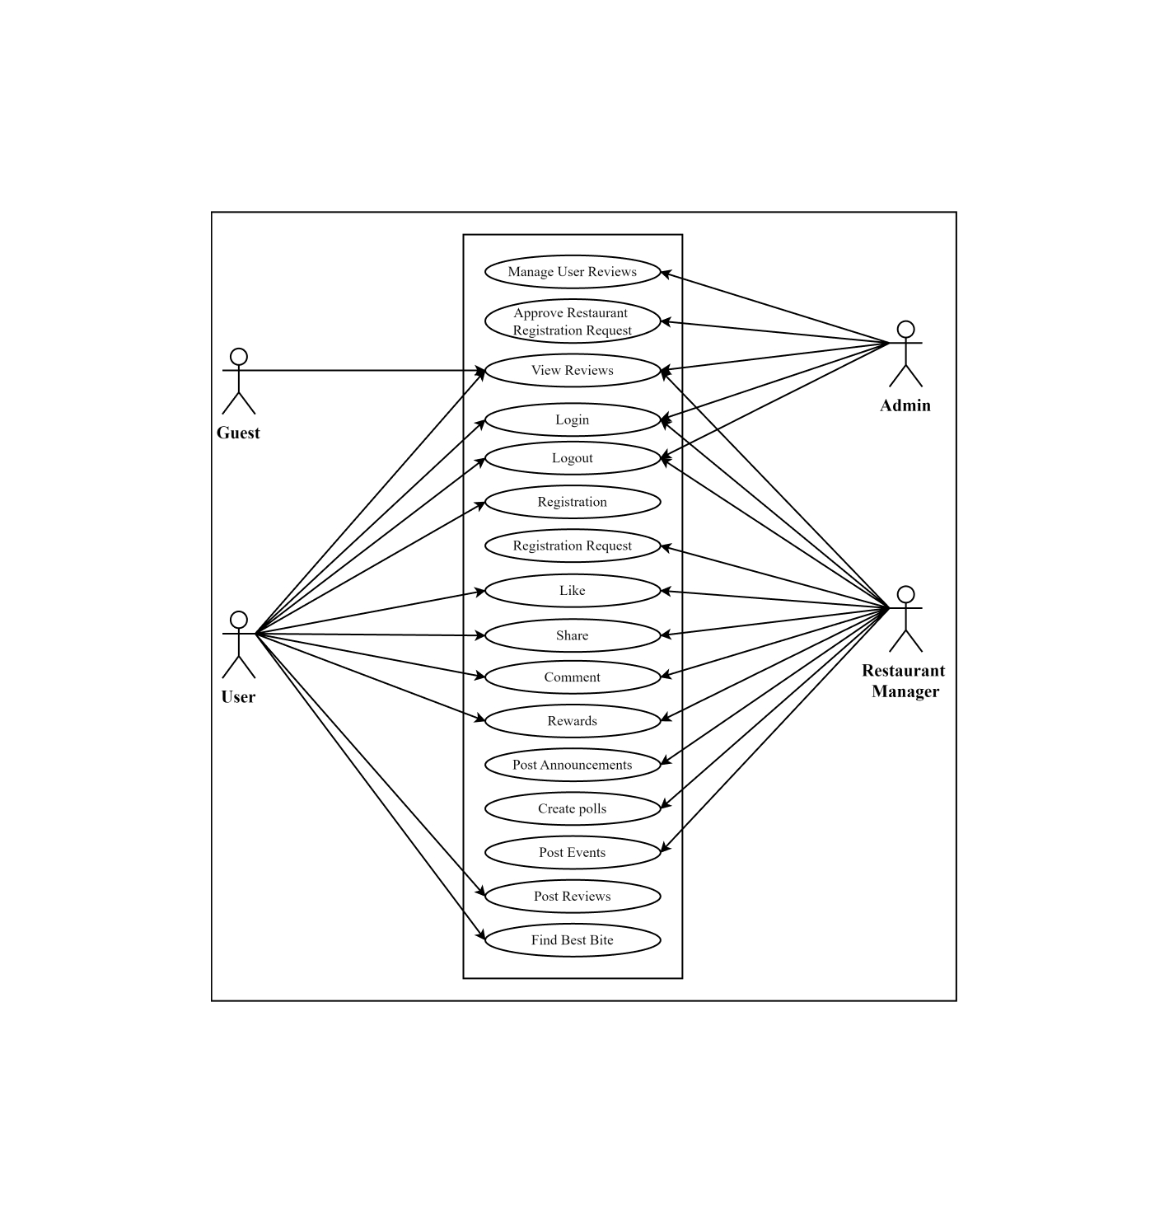
Figure 3.1 Use Case Diagram

Use Case Description
The table below provides a comprehensive use case template filled in with an example drawn from the TasteClip application.
Table 3.1 Use Case: Register
Use case id | UC-01
Use case name | Register
Actors | User
Description | Users can register for an account on the TasteClip platform using their email or social media accounts.
Trigger | The user initiates the registration process.
Precondition | The user is not logged in and does not have an existing account.
Postcondition | A user account is created, and a confirmation email is sent.
Normal flow | The user navigates to the registration page.  User enters the required information (e.g., email, password).  The system validates the information.  The system creates the account and sends a confirmation email.
Alternative flow | If information is invalid, the system prompts the user to correct it.
Exceptions | The system is down and the user receives an error message.
Business rules | Password must meet security requirements.

Table 3.2 Use Case: Login
Use case id | UC-2
Use case name | Login
Actors | User, Restaurant Manager, Admin
Description | Allows user and restaurant manager to log in to the TasteClip application and Admin to access the admin panel.
Trigger | The actor initiates the login process.
Precondition | The actor has a registered account.
Postcondition | An actor is authenticated and granted access to the system.
Normal flow | The actor navigates to the login page.  Actor enters login credentials.  The system verifies credentials.  The system grants access and redirects to the actor’s dashboard.
Alternative flow | If credentials are invalid, the system prompts the actor to retry.
Exceptions | The system is down and the actor receives an error message.
Business rules | Only authenticated users can access the system.

Table 3.3 Use Case: Logout
Use case id | UC-3
Use case name | Logout
Actors | User, Restaurant Manager, Admin
Description | Allows actors to log out of the TasteClip application.
Trigger | The actor initiates the logout process.
Precondition | The actor is logged in.
Postcondition | The actor is logged out, and the session is terminated.
Normal flow | The actor clicks on the logout button.  The system terminates the session.  System redirects to the login page.
Alternative flow | None.
Exceptions | The system fails to terminate the session and the actor receives an error message.
Business rules | All user sessions must be securely terminated.

Table 3.4 Use Case: Registration Request
Use case id | UC-4
Use case name | Registration Request
Actors | Restaurant Manager
Description | Allows a restaurant manager to request registration of their restaurant on TasteClip.
Trigger | The restaurant manager initiates the registration request.
Precondition | Registration request is submitted for approval.
Postcondition | Admin
Normal flow | The restaurant manager navigates to the registration request page.  Restaurant manager enters restaurant details.  The system validates and submits the request.  The system notifies the manager of successful submission.
Alternative flow | If details are invalid, the system prompts for corrections.
Exceptions | The system is down and the manager receives an error message.
Business rules | Only restaurants can request restaurant registration.

Table 3.5 Use Case: Like
Use case id | UC-5
Use case name | Like
Actors | User, Restaurant Manager
Description | Allows users and restaurant managers to like a review or post on TasteClip.
Trigger | The actor clicks the like button on a review or post.
Precondition | The actor is logged in.
Postcondition | The like count on the review or post is incremented.
Normal flow | The actor navigates to a review or post.  Actor clicks the like button.  The system registers the like and updates the like count.
Alternative flow | None.
Exceptions | The system fails to register the like and the actor receives an error message.
Business rules | Each actor can like a review or post only once.

Table 3.6 Use Case: Comment
Use case id | UC-6
Use case name | Comment
Actors | User, Restaurant Manager
Description | Allows users and restaurant managers to comment on a review or post.
Trigger | The actor clicks the comment button and submits a comment.
Precondition | The actor is logged in.
Postcondition | The comment is posted and displayed below the review or post.
Normal flow | The actor navigates to a review or post.  Actor clicks the comment button.  Actor enters a comment and submits it.  The system validates and posts the comments.
Alternative flow | If the comment is invalid, the system prompts for corrections.
Exceptions | The system fails to post the comment and the actor receives an error message.
Business rules | Comments must comply with community guidelines.

Table 3.7 Use Case: Share
Use case id | UC-7
Use case name | Share
Actors | User, Restaurant Manager
Description | Allows users and restaurant managers to share reviews, announcements, or other content on social media platforms.
Trigger | The user or restaurant manager initiates the sharing process.
Precondition | The user or restaurant manager is logged in and viewing content that can be shared.
Postcondition | Content is shared on the selected social media platform.
Normal flow | Actor selects the content they wish to share.  The actor clicks the share button.  The system prompts the actor to select a social media platform.  Actor selects the desired platform.  The system redirects the actor to the platform’s sharing interface.  Actor confirms the share action.  System completes the sharing process and provides confirmation.
Alternative flow | If no platform is selected, the system prompts the actor to choose one.
Exceptions | The social media platform API is down and the actor receives an error message.
Business rules | Only content that complies with community guidelines can be shared.

Table 3.8 Use Case: Post Announcements
Use case id | UC-8
Use case name | Post Announcements
Actors | Restaurant Manager
Description | Allows restaurant managers to post announcements such as promotions, or new menu items.
Trigger | The restaurant manager initiates the announcement posting process.
Precondition | The restaurant manager is logged in and has an active restaurant profile.
Postcondition | The announcement is posted and visible to users.
Normal flow | The restaurant manager navigates to the announcements page.  The restaurant manager clicks on the "Post Announcement" button.  The restaurant manager enters announcement details (e.g., title, description, date). The system validates the details.  The system posts the announcement and notifies the manager of a successful posting.
Alternative flow | If details are invalid, the system prompts the manager to correct them.
Exceptions | The system is down and the manager receives an error message.
Business rules | Announcements must be relevant to the restaurant’s operations and comply with community guidelines.

Table 3.9 Use Case: Create polls
Use case id | UC-9
Use case name | Create polls
Actors | Restaurant Manager
Description | Announcements must be relevant to the restaurant’s operations and comply with community guidelines.
Trigger | The restaurant manager initiates the poll creation process.
Precondition | The restaurant manager is logged in and has an active restaurant profile.
Postcondition | A poll is created and visible to users for voting.
Normal flow | The restaurant manager navigates to the polls page.  The restaurant manager clicks on the "Create Poll" button.  Restaurant manager enters poll details (e.g., questions, options, duration). The system validates the poll details.  The system posts the poll and notifies the manager of successful creation.
Alternative flow | If details are invalid, the system prompts the manager to correct them.
Exceptions | The system is down and the manager receives an error message.
Business rules | Polls must be relevant to the restaurant’s operations and comply with community guidelines.

Table 3.10 Use Case: Post Events
Use case id | UC-10
Use case name | Post Events
Actors | Restaurant Manager
Description | Allows restaurant managers to post details of upcoming events to attract customers.
Trigger | The restaurant manager initiates the event posting process.
Precondition | The restaurant manager is logged in and has an active restaurant profile.
Postcondition | The event is posted and visible to users.
Normal flow | The restaurant manager navigates to the events page.  The restaurant manager clicks on the "Post Event" button.  Restaurant manager enters event details (e.g., title, date, description, location). The system validates the event details.  The system posts the event and notifies the manager of successful posting.
Alternative flow | If details are invalid, the system prompts the manager to correct them.
Exceptions | The system is down and the manager receives an error message.
Business rules | Events must be relevant to the restaurant’s operations and comply with community guidelines.

Table 3.11 Use Case: View Reviews
Use case id | UC-11
Use case name | View Reviews
Actors | User, Guest, Restaurant Manager, Admin
Description | Allows actors to view reviews of restaurants.
Trigger | The actor selects the option to view reviews for a restaurant.
Precondition | The restaurant profile must exist with at least one review.
Postcondition | Reviews are displayed to the actor.
Normal flow | The actor navigates to the restaurant’s profile page.  Actor selects the "View Reviews" option.  The system retrieves and displays the list of reviews.  The actor scrolls through and views reviews.
Alternative flow | If there are no reviews, the system displays a message indicating that no reviews are available.
Exceptions | The system is down and the actor receives an error message.
Business rules | Only approved reviews are displayed.

Table 3.12 Use Case: Post Reviews
Use case id | UC-12
Use case name | Post Reviews
Actors | User
Description | Allows users to post reviews of their dining experience, including text, photos, and videos.
Trigger | The user selects the option to post a review for a restaurant.
Precondition | The user must be logged in and have dined at the restaurant being reviewed.
Postcondition | The review is submitted and awaits moderation.
Normal flow | The user navigates to the restaurant’s profile page.  The user selects the "Post Review" option.  User enters review details (text, photos, and videos). The system validates the review content.  The system submits the review for moderation.  The system notifies the user that the review has been submitted successfully.
Alternative flow | If review details are invalid, the system prompts the user to correct them.
Exceptions | The system is down and the user receives an error message.
Business rules | All reviews must comply with community guidelines.

Table 3.13 Use Case: Find Best Bite
Use case id | UC-13
Use case name | Find Best Bite
Actors | User
Description | Users play a game where the system reads their minds to determine what they want to eat by answering multiple-choice questions.
Trigger | The user navigates to the game section and clicks "Start".
Precondition | The user is on the app and can access the game section.
Postcondition | The user receives a result suggesting a dish.
Normal flow | The user navigates to the Find Best Bite game section.  The user starts the game.  The user answers a series of questions.  System processes responses.  The system provides results in the form of dishes
Alternative flow | The system encounters a technical issue and displays an error message.  The user retries or returns to the main menu.
Exceptions | The system is down and the user receives an error message.
Business rules | Results are based on recent and relevant review data.

Table 3.14 Use Case: Manage User Reviews
Use case id | UC-14
Use case name | Manage User Reviews
Actors | Admin
Description | Allows admins to review, approve, edit, or delete user-submitted reviews to ensure they comply with community guidelines.
Trigger | Admin logs into the system and selects the option to manage user reviews.
Precondition | Admin must be logged in with the appropriate privileges.
Postcondition | User reviews are updated based on admin actions (approved, edited, or deleted).
Normal flow | Admin navigates to the "Manage User Reviews" page.  The system displays a list of pending reviews.  Admin selects a review to manage.  Admin reviews the content of the selected review.  Admin decides to approve, edit, or delete the review.  The system updates the review status accordingly.  The system notifies the user of the review status change.
Alternative flow | If the review violates guidelines, the admin edits the review or provides feedback to the user.
Exceptions | The system is down and the admin receives an error message.
Business rules | Only reviews that comply with community guidelines are approved.

Table 3.15 Use Case: Approve Restaurant Registration Request
Use case id | UC-15
Use case name | Approve Restaurant Registration Request
Actors | Admin
Description | Allows admins to review and approve or reject registration requests from restaurant managers who want to list their restaurants on the platform.
Trigger | Admin logs into the system and selects the option to manage registration requests.
Precondition | Admin must be logged in with the appropriate privileges.
Postcondition | Restaurant registration requests are either approved or rejected, and the restaurant manager is notified of the decision.
Normal flow | Admin navigates to the "Manage Registration Requests" page.  The system displays a list of pending registration requests.  Admin selects a registration request to review.  Admin reviews the details of the registration request.  Admin decides to approve or reject the request.  The system updates the status of the registration request.  The system notifies the restaurant manager of the approval or rejection.
Alternative flow | If additional information is required, the admin requests more details from the restaurant manager.
Exceptions | The system is down and the admin receives an error message.
Business rules | Only complete registration requests are processed.  Approved restaurants must meet the platform's standards and guidelines.

Table 3.16 Use Case: Rewards
Use case id | UC-16
Use case name | Rewards
Actors | Manager, User
Description | Allows restaurant managers to post reward offers to encourage customer participation and loyalty. Users are also rewarded for their contributions, enhancing engagement and fostering a sense of involvement.
Trigger | The restaurant manager initiates the reward posting process, or a user meets the criteria for earning a reward.
Precondition | The restaurant manager is logged in with an active restaurant profile; the user has provided eligible feedback or completed an action that meets the reward criteria.
Postcondition | The reward is posted and visible to eligible users, or the user receives a reward based on their feedback.
Normal flow | The restaurant manager navigates to the rewards page.  The restaurant manager clicks on the "Post Reward" button.  The restaurant manager enters reward details (e.g., reward type, points required, description, conditions).  The system validates the reward details.  The system posts the reward and notifies the manager of successful posting.  The system monitors user feedback for popularity, and eligible users receive rewards based on their contributions.  The system notifies users when they earn a reward.
Alternative flow | If details are invalid, the system prompts the manager to correct them.  If the reward conditions are not met by a user’s feedback, no reward is given.
Exceptions | The system is down, and the manager or user receives an error message.
Business rules | Rewards must be relevant to the restaurant’s offerings and comply with community guidelines.  User rewards are based on the popularity and quality of their feedback (e.g., number of likes or helpfulness rating).  Rewards should incentivize customer engagement and meaningful actions.

Functional Requirements
The functional requirements of the TasteClip system define the key operations and capabilities the application must support to fulfill its purpose. These requirements ensure that the system meets the needs of users (both consumers and restaurant managers) by providing core functionalities such as user registration, video-based review submission, moderation workflows, profile management, and intelligent search capabilities. Each requirement is aimed at delivering a seamless, secure, and engaging user experience across different modules of the platform.

User Registration and Authentication
This functionality ensures that users can securely create and access their TasteClip accounts. It supports registration via email and social platforms like Google or Facebook, providing convenience and flexibility. Once registered, a confirmation email is sent to verify the identity of the user. This process forms the foundation for secure access, as all subsequent activities, such as posting reviews or accessing rewards, require verified login credentials. Adhering to data protection standards is critical to safeguarding user information and maintaining platform integrity.
Table 3.17 Functional Requirement: User Registration and Authentication
Identifier | FR-1
Title | User Registration and Authentication
Requirement | The user shall be able to register an account using an email address or social media accounts (e.g., Facebook, Google). Upon successful registration, the system shall send a confirmation email to the user. The system shall allow users to log in using their registered credentials.
Source | Stakeholder interviews
Rationale | To ensure only authenticated users can access the platform.
Business Rule (if required) | User data must be securely stored and handled as per data protection regulations.
Dependencies | None
Priority | High

Review Submission
This feature allows users to contribute multimedia-based restaurant reviews, enriching the platform’s content with dynamic and immersive feedback. Users can upload videos, photos, and descriptive text to convey their dining experiences more vividly than traditional text-based reviews. To ensure optimal platform performance, content uploads are restricted to a certain size limit. This function is integral to TasteClip’s unique identity, encouraging user engagement and authentic storytelling through visual reviews.
Table 3.18 Functional Requirement: Review Submission
Identifier | FR-2
Title | Review Submission
Requirement | The user shall be able to submit reviews in the form of videos, photos, and text. The system shall allow users to upload multimedia content up to a specified size limit.
Source | Market analysis
Rationale | To provide a dynamic and engaging review format.
Business Rule (if required) | All submitted content must be moderated to ensure it complies with community guidelines.
Dependencies | FR-1
Priority | High

Review Moderation
To maintain community standards and prevent inappropriate or misleading content, all user-submitted reviews are subject to moderation. Admins have the authority to approve or reject reviews based on predefined guidelines. This ensures that only relevant, respectful, and constructive content appears on the platform. Moderation also promotes trust among users by maintaining the quality and reliability of the information presented. Timely review processing (within 24 hours) is mandated to ensure responsiveness and user satisfaction.
Table 3.19 Functional Requirement: Review Moderation
Identifier | FR-3
Title | Review Moderation
Requirement | The admin shall be able to review and approve or reject user-submitted feedbacks. The system shall notify users of the status of their review submission.
Source | Stakeholder interviews
Rationale | To maintain content quality and community standards.
Business Rule (if required) | Reviews must be moderated within 24 hours of submission.
Dependencies | FR-2
Priority | Medium

Restaurant Profile Management
Restaurant managers can create and manage their business profiles within the app. This includes uploading essential content such as the restaurant’s images, menu, location, and special offers. These profiles serve as digital storefronts that attract potential customers and improve restaurant visibility. To prevent unauthorized listings and ensure credibility, only verified restaurant owners are allowed to create and manage profiles. This feature strengthens the B2C connection by giving restaurants a direct channel to engage with users.
Table 3.20 Functional Requirement: Restaurant Profile Management
Identifier | FR-4
Title | Restaurant Profile Management
Requirement | Restaurant owners shall be able to create and manage their profiles. The system shall allow restaurant owners to upload images, menus, and other relevant information.
Source | Stakeholder interviews
Rationale | To provide comprehensive information about the restaurant to potential customers.
Business Rule (if required) | Only verified restaurant owners can create profiles.
Dependencies | FR-1
Priority | High

Search and Discovery
The search and discovery module allows users to explore dining options efficiently using filters such as location, cuisine type, and ratings. This functionality supports user decision-making by delivering relevant and tailored search results. Intelligent sorting and filtering mechanisms enhance the overall browsing experience, ensuring that users can quickly find restaurants that match their preferences. Keeping the search results up-to-date and relevant is crucial for maintaining user trust and satisfaction.
Table 3.21 Functional Requirement: Search and Discovery
Identifier | FR-5
Title | Search and Discovery
Requirement | The user shall be able to search for restaurants based on location, cuisine, and user ratings. The system shall provide filters and sorting options to refine search results.
Source | Market analysis
Rationale | To enhance user experience in finding suitable dining options.
Business Rule (if required) | Search results must be relevant and up-to-date.
Dependencies | FR-4
Priority | High

Non-Functional Requirements
The TasteClip project not only emphasizes the delivery of key functional capabilities but also ensures the incorporation of essential non-functional requirements. These are critical for the system’s success in real-world scenarios and help meet user expectations beyond the basic feature set. The non-functional requirements contribute to user satisfaction, system robustness, operational efficiency, and technological sustainability. They are designed to address aspects such as usability, performance, security, portability, reliability, maintainability, and scalability, covering all major quality attributes of a modern cross-platform application.

Usability
Usability plays a central role in the success of any user-facing application. TasteClip is designed with a strong focus on providing a highly intuitive and user-friendly interface that accommodates users of various technical skill levels. The application features a modern aesthetic with responsive navigation, minimizing the learning curve and making it easy for users to explore and engage with the platform. Interactive features such as drag-and-drop video uploads, real-time content previews, swipe gestures, and floating action buttons enhance the overall interactivity of the user experience. The design also strictly adheres to the Web Content Accessibility Guidelines (WCAG), incorporating features like voice-over support, high-contrast color modes, and adjustable text sizes to ensure inclusivity for users with disabilities. These usability enhancements aim to foster engagement, encourage content contribution, and improve retention for both consumers and restaurant managers.

Performance
Performance is a core consideration for TasteClip, given its reliance on real-time video content and user interactions. The system is engineered for high responsiveness and optimized latency through the integration of efficient media compression algorithms, content delivery networks (CDNs), and load balancing techniques. Asynchronous processing methods are used to handle background tasks like content moderation and reward assignments, ensuring that the user interface remains fluid during heavy operations. The use of caching for frequently accessed data further accelerates content loading, especially for trending reviews or nearby restaurant suggestions. Performance testing, including stress testing and load simulations, will be conducted regularly to validate the system’s behavior under various usage conditions. These optimizations collectively guarantee a seamless user experience even during peak traffic hours.

Security
Security is a critical priority for TasteClip, given the platform’s handling of sensitive user data—including video reviews, user profiles, and restaurant credentials—and the need for secure digital interactions. The system adopts a multi-layered security architecture combining Firebase, Laravel, and Flutter components. User authentication and authorization are managed securely through Firebase Authentication, which supports secure sign-in methods via email/password and OAuth providers like Google. Access to resources is controlled using role-based access control (RBAC), clearly separating permissions for consumers, restaurant managers, and administrators.
All sensitive data is encrypted in transit using HTTPS (TLS 1.3) and securely stored in Firebase Firestore and Firebase Storage, which implement encryption at rest. On the web admin side, Laravel’s built-in CSRF protection, input validation, and sanitization mechanisms guard against common web-based attacks such as SQL Injection, Cross-Site Scripting (XSS), and Cross-Site Request Forgery (CSRF). In the mobile app, Flutter's secure API communication patterns (like HTTPS-based REST calls with token-based access) ensure data confidentiality.
Additionally, real-time monitoring tools such as Firebase Security Rules, Firebase App Check, and Crashlytics are used to log suspicious activities and system exceptions. Regular audits of dependencies, use of environment variables for API keys and tokens, and limited exposure of sensitive backend endpoints through Firebase Firestore security policies further enhance the system’s resilience. These combined measures ensure that user data remains protected, only authorized access is allowed, and trust is maintained across all user roles.

Portability
Portability ensures that TasteClip remains accessible and consistent across a range of devices and environments. The mobile application is developed using Flutter, allowing it to run natively on both Android and iOS with a single codebase. Responsive design principles are applied to maintain a consistent layout and user experience across different screen sizes, including smartphones and tablets. The web-based admin panel is developed using Laravel and modern frontend technologies, ensuring compatibility with all major browsers such as Chrome, Firefox, Edge, and Safari. Furthermore, the platform is designed to be deployable on cloud services like Firebase Hosting, Google Cloud, or AWS, offering flexibility in hosting options and making it easy to migrate or scale the application to different infrastructures. This cross-platform capability ensures maximum user reach and convenience.

Reliability
Reliability is another cornerstone of the TasteClip architecture, guaranteeing service continuity and data integrity. The backend infrastructure incorporates cloud-based redundancy, automatic failover mechanisms, and database replication to prevent data loss and ensure uptime even during system failures. Comprehensive error handling, centralized logging using tools like Firebase Crashlytics, and real-time monitoring help quickly detect and resolve issues before they affect the user experience. The system is backed up regularly, and a disaster recovery plan is in place to restore services in case of critical failures. Continuous uptime monitoring and failover testing are conducted to ensure that any unexpected downtime is minimized and users experience uninterrupted access to the platform.

Maintainability
Maintainability is equally important for ensuring that the system can evolve and adapt to changing requirements. The project follows modular design principles and maintains clean, well-documented code using DartDoc for Flutter and PHPDoc for Laravel. The use of the Model-View-Controller (MVC) architecture on the web and GetX for state management in Flutter ensures a separation of concerns, making it easier to modify or add new features. All code is version-controlled using Git, with development best practices such as feature branching and pull requests enforced to streamline collaboration and debugging. External packages and dependencies are regularly updated to maintain compatibility and security, reducing long-term technical debt and simplifying future enhancements.

Scalability
Scalability ensures that TasteClip can grow with its user base and support increasing demand. The system architecture is designed for both horizontal and vertical scalability. Horizontal scaling is achieved through replication of services and functions, especially in Firebase and cloud infrastructure, allowing the platform to handle thousands of concurrent users and high volumes of video uploads. Vertical scalability is supported by upgrading compute resources in the Laravel backend as needed. Firestore, as a NoSQL database, is used for high-frequency read and write operations, while Firebase Cloud Storage offers scalable storage for user-uploaded videos. These design choices ensure that the platform remains performant and stable as it expands regionally or incorporates new features.

Chapter 4
Design and Architecture

Design and Architecture

System Architecture
The Architecture Diagram image represents the microservices architecture of the TasteClip application. At the core is a centralized Micro-Services layer that connects and coordinates with several independent functional modules, promoting scalability and maintainability. These modules include Feedback Management, User Management, Manager Management, Reward Management, and Admin Management, each handling distinct responsibilities within the system.
Feedback Management is linked to Social Media Sharing, allowing approved reviews to be shared externally. User Management integrates with an AI Module, which likely powers personalized recommendations or fraud detection. Similarly, Manager Management connects with Event Management, enabling restaurant managers to organize and promote events. Each module operates independently yet communicates through the microservices layer to ensure smooth, real-time interactions across the application.
This architecture aligns with the client-server model of TasteClip, where a Flutter-based mobile app communicates via RESTful APIs with a Firebase-powered backend. The structure enhances performance, enables real-time data handling, and supports modular updates, ensuring an efficient and reliable experience for users and restaurants alike.
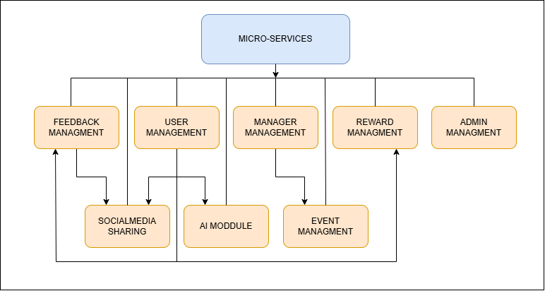
Figure 4.1 Architecture Diagram

Process Flow Representation
The Process Flow Diagram illustrates a role-based process flow for a multi-user system comprising Admin, Manager, and User roles. The flow begins with a role selection step, directing users based on their chosen role. Admins sign in to access a dashboard where they manage event details, user and restaurant details, feedback, and manager requests. Admins can accept or reject manager registration requests and notify them via email. They also handle feedback approval, where feedback can be accepted or dismissed, triggering appropriate notifications.
Managers follow a verification step post sign-in. Upon verification, they gain access to various functionalities including managing events, sending notifications, handling channel details, gifting coins, and watching or approving feedback. If feedback is unresolved or flagged, managers are notified and can take appropriate actions. Users can either sign up or sign in. Verified users access features such as watching events, using the “Find Best Bite” feature, viewing their profile and earned coins, and uploading feedback. Submitted feedback is routed for approval, with notifications keeping users updated on status changes.
Throughout the system, notifications are consistently used across all roles to ensure communication and task completion. The process flow ensures a streamlined experience, with each role equipped with features relevant to their responsibilities, facilitating efficient management and interaction within the application.

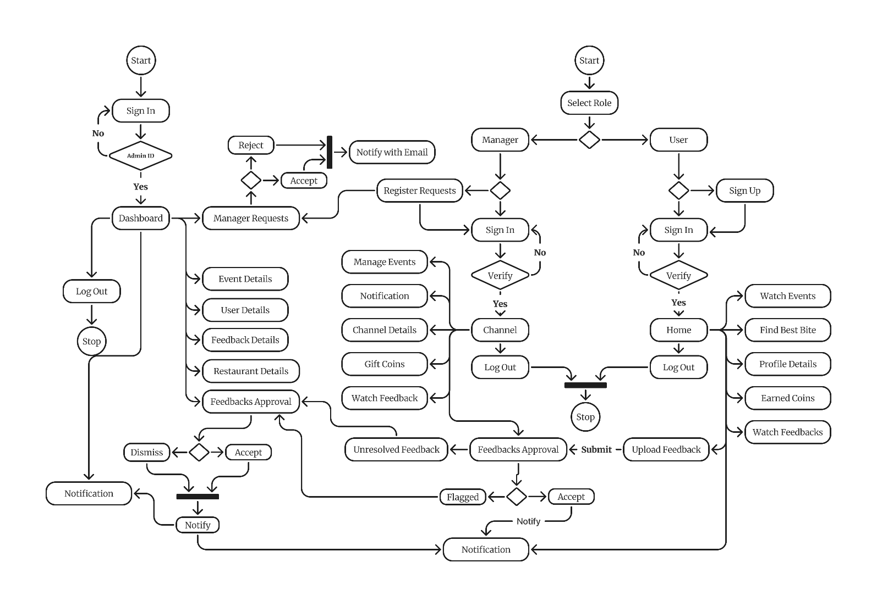
Figure 4.2 Process Flow Diagram

Sequence Diagram
The sequence diagram visually represents the operational flow within the TasteClip app, focusing on the feedback submission and approval process. It begins when a user signs in and uploads feedback related to a restaurant experience. This feedback is then routed to the respective restaurant channel, where both the manager and admin play key roles in the review process. The manager initially reviews the feedback, flags any issues if necessary, and forwards it for final approval. The admin then either accepts or rejects the feedback based on platform guidelines.
If the feedback is approved, a notification is sent, and the content becomes publicly visible to other users on the app. In cases where feedback is flagged or unresolved, it enters a pending state, prompting further action and communication between the manager and admin. Notifications are integral throughout this process, keeping all stakeholders informed of status updates, approvals, or dismissals. The sequence ensures a transparent and secure approach to handling user-submitted feedback, maintaining quality and authenticity. Overall, the diagram outlines a collaborative and controlled system where user content is verified before publication to uphold trust within the TasteClip community.

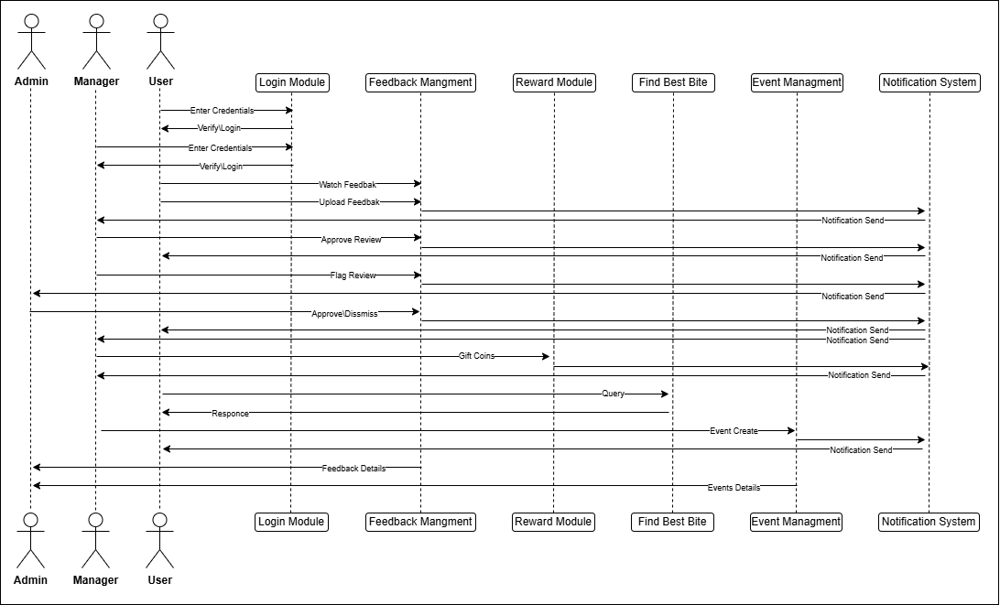
Figure 4.3 Sequence Diagram

Class Diagram
The provided class diagram represents the TasteClip system, detailing the structure and relationships among various classes that support functionalities such as user feedback management, event handling, user registration, reward allocation, and system administration. At the core, the system supports User registration through the Signup class, where each user has associated personal details and a Profile. Users can log in via App Login or Web Login, with separate handling of authentication credentials. Users can upload different types of feedback—Image Feedback, Text Feedback, and Video Feedback—through the Feedback Upload class, where feedback is associated with a type, timestamp, and user details.
Users can also engage with the feedback of others through the Watch Feedback class, which allows actions like liking and sharing. For their contributions and interactions, users are incentivized through the Reward class, which records rewards earned based on system-defined criteria. The Manager class serves as an intermediary entity responsible for managing user feedback, approving or flagging feedback via the Feedback Approval class, handling Registration Requests, and organizing Events and Channels. Managers also have the ability to gift coins and manage events for specific channels.
Above the managers is the admin, who holds system-wide control, including approving flagged feedback, dismissing reviews, managing channel registration requests, and accessing the Dashboard. The Dashboard provides an overview of system statistics such as total users, total feedback, events, and registered restaurants, offering valuable insights for administrative decision-making.
Overall, the system is carefully structured to ensure secure user management, transparent feedback workflows, and reward mechanisms, while providing hierarchical oversight from managers to admins. The design promotes user engagement, content moderation, and efficient management of events and channels, contributing to a robust and interactive feedback ecosystem.
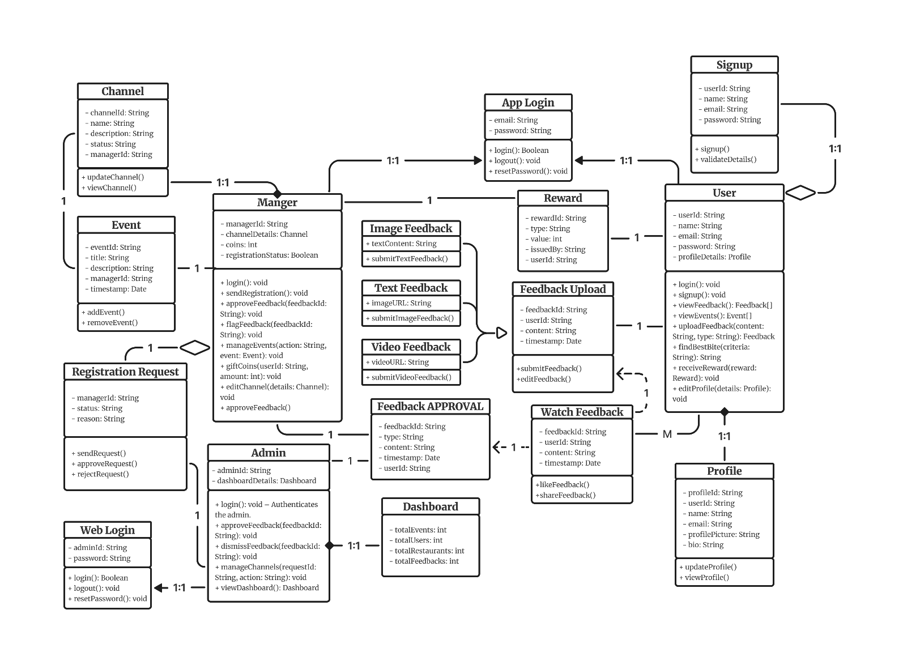
Figure 4.4 Class Diagram

Chapter 5
Implementation

Implementation
In the implementation phase of TasteClip that is a Food Review & Reward Platform, we focused on developing a secure, responsive, and interactive application that facilitates a seamless experience for both food lovers and restaurant managers. The core objectives during this phase were to integrate all planned functionalities, ensure robust communication with the backend (Firebase), and implement intuitive user interfaces with smooth interactions across different roles. The implementation phase involved multiple key steps as detailed below:
- Setup Development Environment:
- The mobile application was developed using Flutter, which supports both Android and iOS platforms. The frontend emphasized rich user interactions and clean navigation flows.
- The backend services including authentication, storage, Firestore database, and messaging were integrated using Firebase.
- For admin operations, a Laravel-based web dashboard was developed and connected to the same Firebase database through RESTful APIs and SDKs.
- Firebase Emulator Suite and Laravel Homestead (for local testing) were used during development for consistency and simulation of live environments.
- Database Design and Implementation:
- A cloud-based NoSQL schema was designed using Firebase Firestore to manage users (consumers and restaurant managers), reviews, coins, restaurant data, events, and offers.
- The schema included collections such as Users, Restaurants, Reviews, Channels, Events, Offers, Coin Transactions, and Notifications.
- Rules were implemented for secured data access and retrieval using Firebase Security Rules.
- Optimized querying and pagination were configured for smooth content loading and performance in modules like review watching, event listings, and restaurant browsing.
- The Laravel admin panel directly accesses the same Firestore data using SDK-based middleware and secured REST APIs.
- Firebase Security Rules were applied to ensure that users can only access their permitted data.
- User Authentication and Authorization:
- User authentication was handled through Firebase Authentication, supporting both email/password and third-party sign-ins (Google).
- Role-based access was implemented by maintaining role metadata (user, manager, admin) in the Firestore database to dynamically adjust access and navigation.
- Secure login sessions were maintained, and sensitive operations were restricted based on the authenticated user’s role.
- Laravel’s admin panel enforces access control through API token middleware and role checks to ensure content moderation is only performed by authorized personnel.
- User Interface Design:
- The UI was designed using Flutter widgets and Material Design principles to ensure consistency, interactivity, and modern aesthetics.
- Animations were added using Animated Container, Fade Transition, and custom transitions to improve user engagement.
- Different navigation flows were developed for each user type, including:
    - Consumers: Watch and upload reviews, earn and redeem coins, explore best bites, and interact with restaurants.
    - Restaurant Managers: Post events and offers, manage restaurant profiles, handle review approvals, and communicate with admin.
    - Admins: Monitor system activities, handle reports, and manage user roles and content via Laravel panel.
- Review and Content Management Module:
- Consumers can upload three types of reviews: text, photo, or video.
- Uploaded videos are stored in Firebase Storage with metadata stored in Firestore.
- Each review supports captions, categories, likes, comments, and engagement stats.
- Restaurant Managers review incoming feedback before approval.
- The Review Watch Screen enables continuous scrolling of trending or relevant video content.
- Reward System and Coin Management:
- A coin-based reward system rewards consumers for uploading reviews, watching content, or engaging with events.
- Managers can transfer coins to users via the panel for marketing or loyalty rewards.
- Real-time coin balances are updated using Firebase Cloud Functions.
- Events, Offers, and Channels Module:
- Restaurant Managers can create and post events or promotional offers in the form of cards under their custom channels.
- Users can follow specific restaurant channels and get notified of new offers, discounts, or food festivals.
- Each event/offer supports text, image, validity dates, and categories for better targeting and presentation.
- Notification and Interaction Module:
- Real-time notifications are delivered using Firebase Cloud Messaging (FCM) for:
- New review approvals.
- Coin transfers.
- New events/offers in followed channels.
- Notification data is stored and displayed in-app for easy reference.
- Location-Based Restaurant Discovery:
- The “Find Best Bite” feature uses user preferences and location to recommend top-rated nearby restaurants.
- Restaurants are filtered by rating, category, distance, and offers to optimize the browsing experience.
- Admin Module:
- The web-based admin panel developed in Laravel includes:
  - Access to all Firestore collections using Firebase SDK integration.
  - Role-based dashboards for reviewing flagged reviews, approving managers, and managing events.

Algorithm
The general algorithm flow for the TasteClip is as follows:
- Start the app.
- Display splash screen and route to authentication module.
- Authenticate user and load role-based dashboard (Consumer / Manager).
- If consumer:
- Explore best-rated restaurants based on location.
- Watch reviews, like videos, and earn coins.
- Upload a new review and receive coin rewards.
- View restaurant offers and upcoming food events.
- If manager:
- Post offers, events, and promotions.
- View incoming reviews and approve or report them.
- Transfer coins to loyal customers.
- Monitor user interactions and restaurant performance.
- Access notification module for real-time updates.
- Logout or terminate session.

User Interface
The TasteClip interface is designed with simplicity and engagement in mind, balancing user expectations and functional needs. It supports three primary roles: Consumers, Restaurant Managers, and Administrators, each with tailored user experiences. These interfaces aim to offer intuitive navigation, visual richness, and interactive feedback features for a seamless user journey.

Consumer Interface
The consumer-facing interface is designed to promote exploration, user-generated video reviews, and AI-assisted discovery of food places. Below is a breakdown of the interface screens and their purposes:
- Role Selection:
This screen allows users to choose their role before proceeding. It segregates users into Consumers or Managers, ensuring role-specific flows. The visual design clearly separates each option with representative icons and a friendly UI layout.
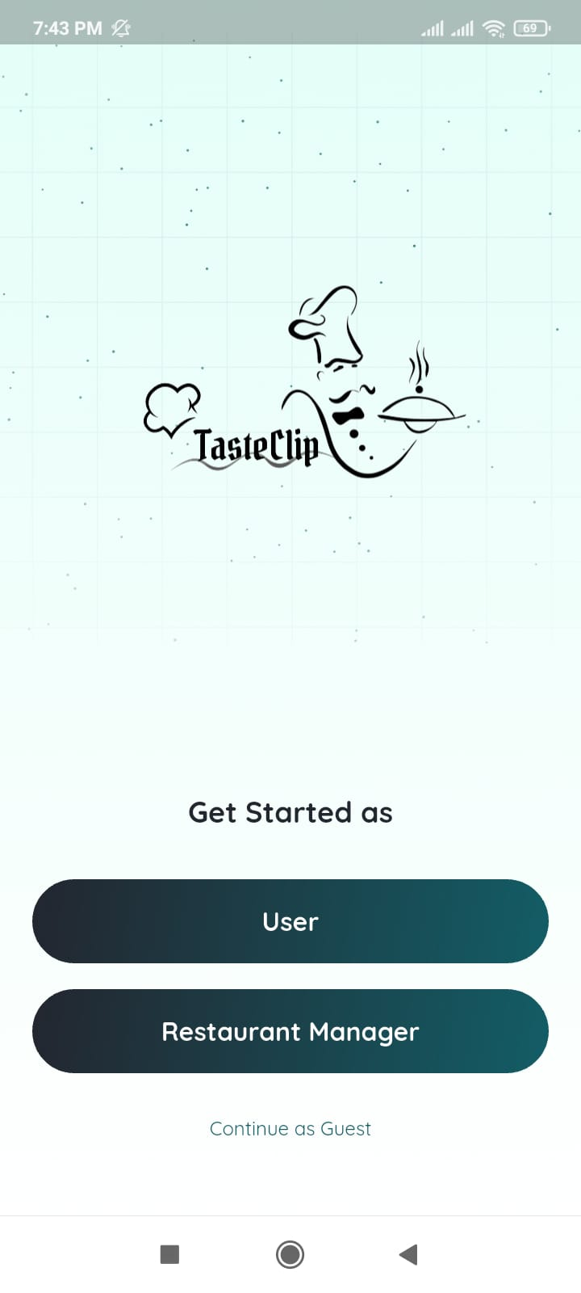
Figure 5.1 Role Selection Screen
- Registration:
New users enter basic details for account creation. The form is straightforward and mobile-optimized, integrating Firebase authentication.

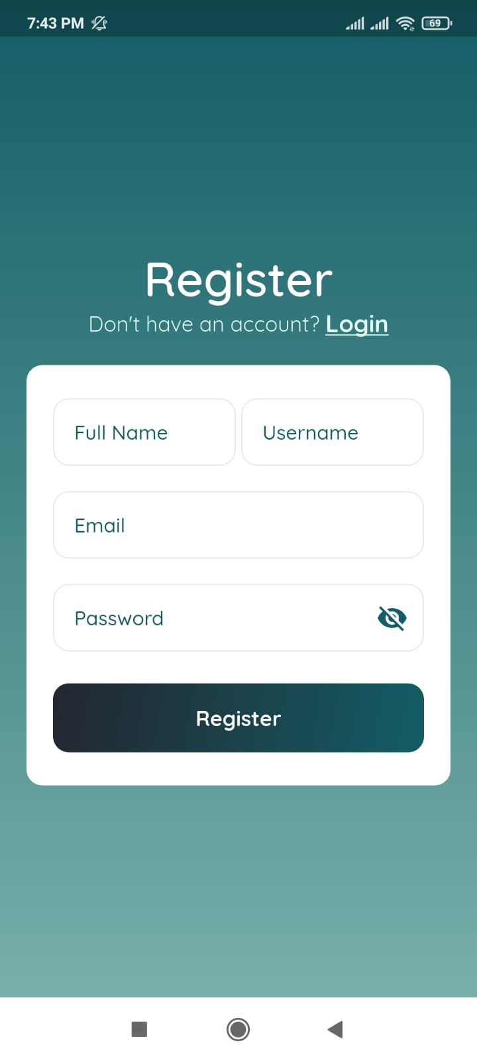
Figure 5.2 Registration Screen
- Login:
Allows existing users to log in securely. Input fields are styled with proper feedback messages for invalid credentials or empty fields.

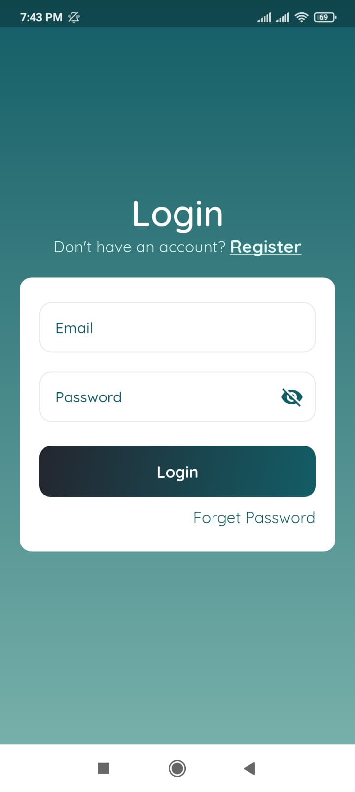
Figure 5.3 Login Screen
- Home Interface:
Displays trending video reviews, current offers, and nearby restaurant recommendations. A card-based layout and horizontal scroll enhance discoverability.
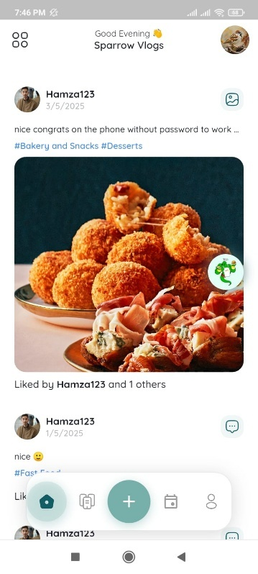
Figure 5.4 Home Screen
- Feedback Type Selection:
Users choose whether to record a new review or upload an existing video. Visual tiles represent each option, simplifying interaction.
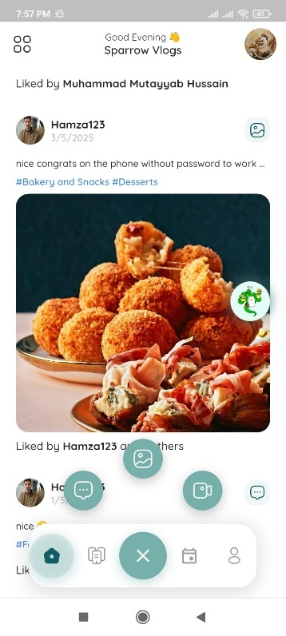
Figure 5.5 Feedback Type Selection Screen
- Restaurant Selection:
A searchable dropdown helps users pick a restaurant before uploading a review.
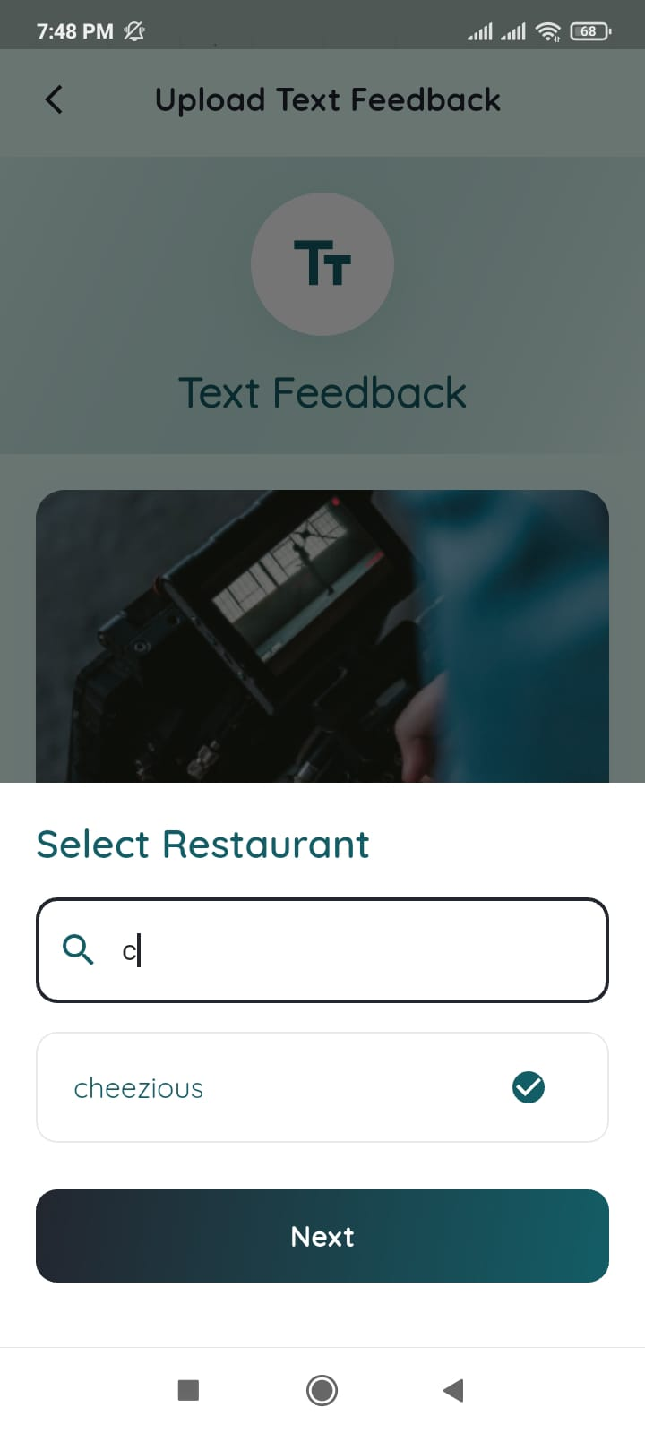
Figure 5.6 Restaurant Selection Screen
- Restaurant Branch Selection:
Once a restaurant is selected, users pick the specific branch to link their review accurately.
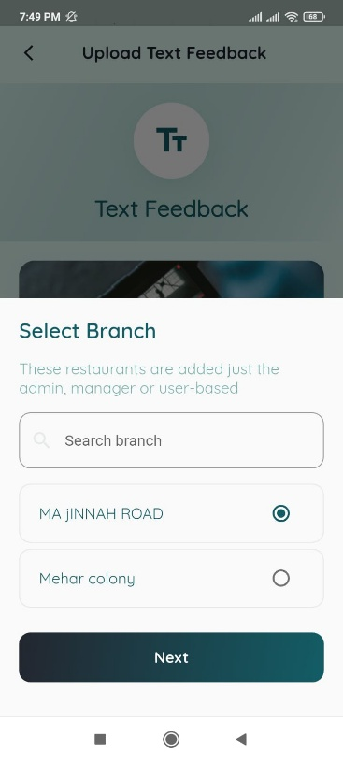
Figure 5.7 Restaurant Branch Selection Screen
- Upload Review:
Supports video recording/uploading with description, tags, and auto-thumbnail generation. Upload progress is shown with a progress bar.
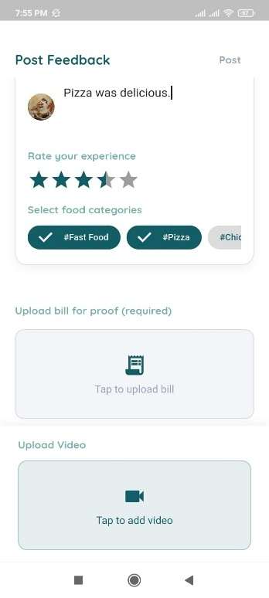
Figure 5.8 Upload Review Screen
- Review Watch Screen:
This scrollable video feed showcases trending or AI-recommended reviews. Autoplay and swipe gestures create an engaging experience similar to Instagram Reels.
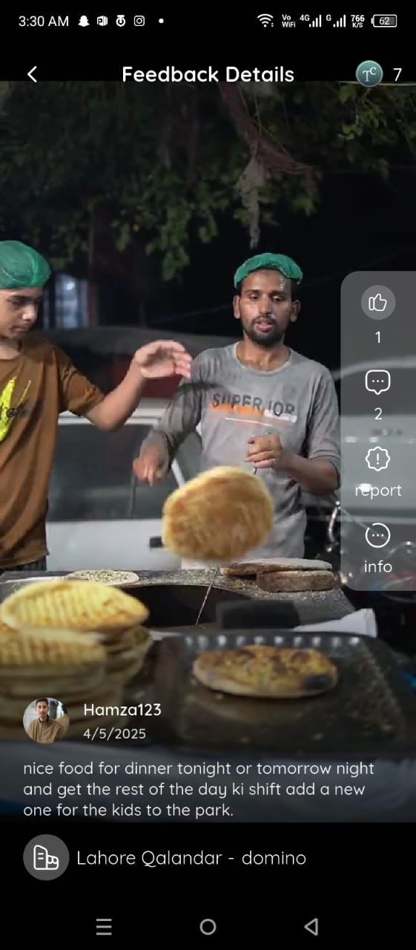
Figure 5.9 Review Watch Screen
- Find Best Bite:
An interactive map highlights top-reviewed restaurants using geolocation and user feedback. Filters are available by rating, cuisine, and distance.
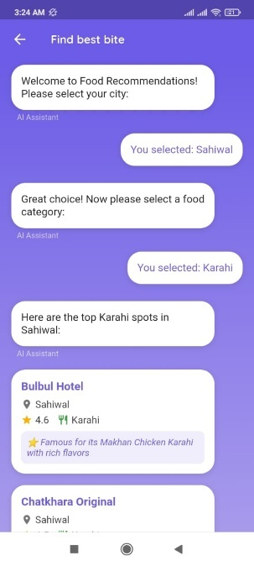
Figure 5.10 Find Best Bite Screen

Restaurant Manager Interface
The restaurant manager interface enables food businesses to manage their digital presence, respond to feedback, and promote events and deals.
- Channel Registration:
Restaurant managers can sign up by providing establishment details, documents, and branch information.

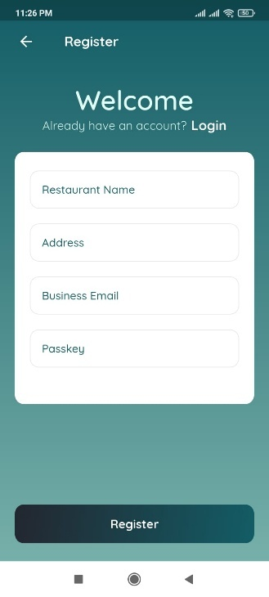
Figure 5.11 Channel Registration Screen
- Manager Login:
Enables secure access to the manager panel using verified credentials.
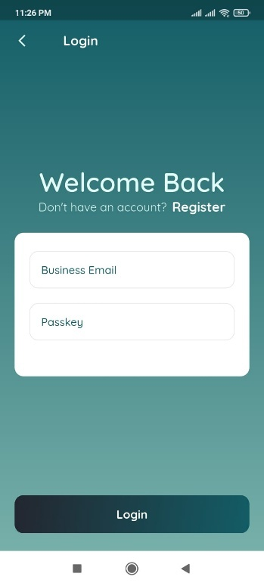
Figure 5.12 Manager Login Screen

- Waiting for Approval:
Indicates pending admin approval post-registration. This enhances transparency in the onboarding process.
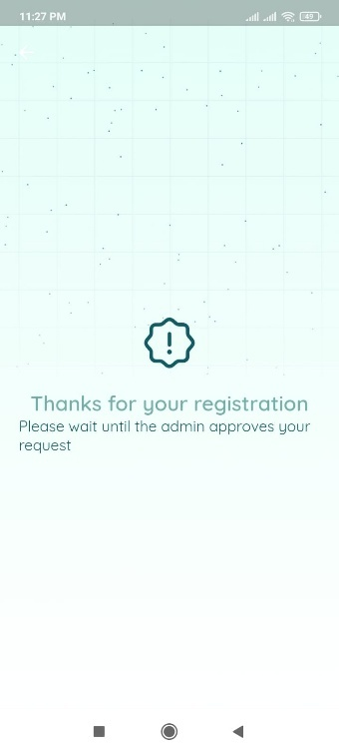
Figure 5.13 Waiting for Approval Screen
- Manager Dashboard:
The main hub for restaurant managers. They can view analytics, recent feedback, event activity, and more. Tabs separate key functionalities for easy navigation.
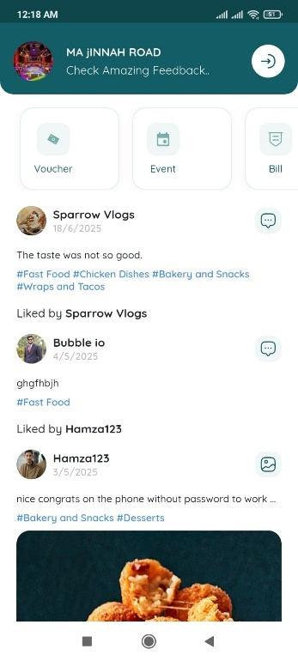
Figure 5.14 Channel (Manager Dashboard)
- Review Summary:
Shows charts and metrics about customer reviews including average rating, engagement trends, and top feedback tags.

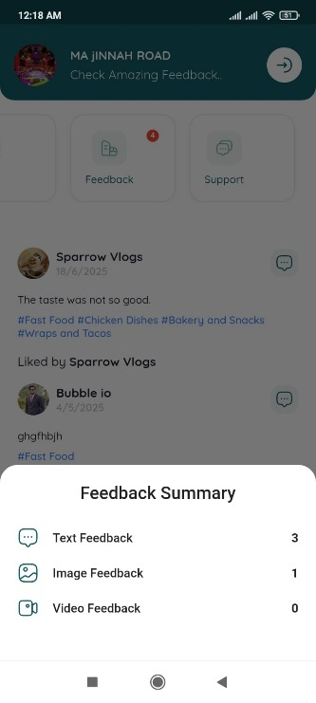
Figure 5.15 Feedback Summary Screen
- Review Reporting:
Lists detailed user reviews, allowing managers to report false feedback or respond to users directly.
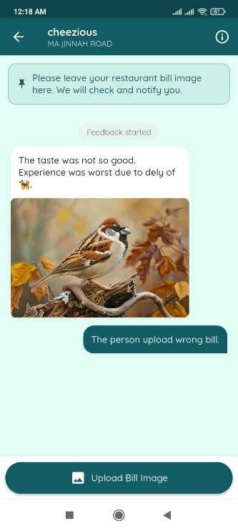
Figure 5.16 Feedback Report Screen
- Vouchers Creation:
A form where managers can define discounts, promo codes, expiration dates, and minimum spending limits.

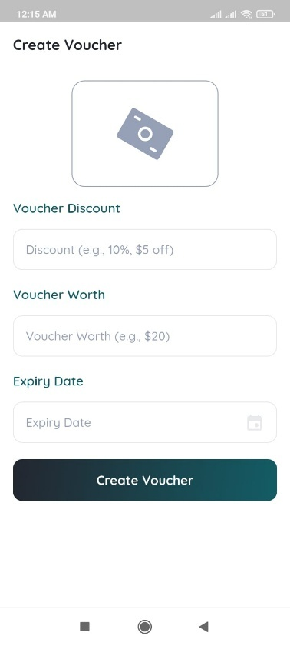
Figure 5.17 Create Voucher Screen

- Event Creation:
Displays all scheduled and past events in card format. Managers can edit, duplicate, or cancel events as needed.
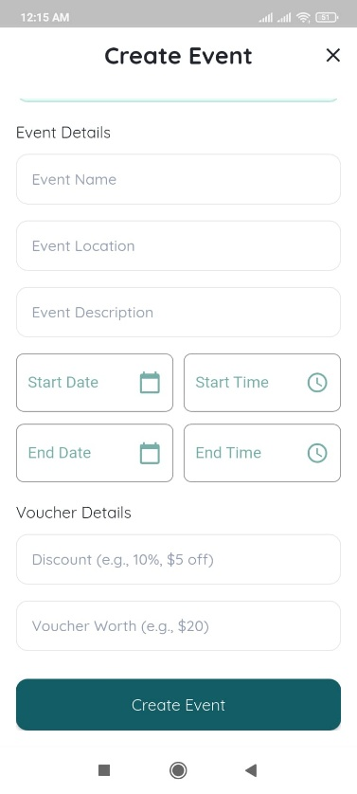
Figure 5.18 Create Event Screen

Admin Interface
The admin interface provides tools for system-wide monitoring, moderation, and control, ensuring platform integrity and security.
- Admin Login:
Admins authenticate securely through this login interface. Access is limited to verified backend users..
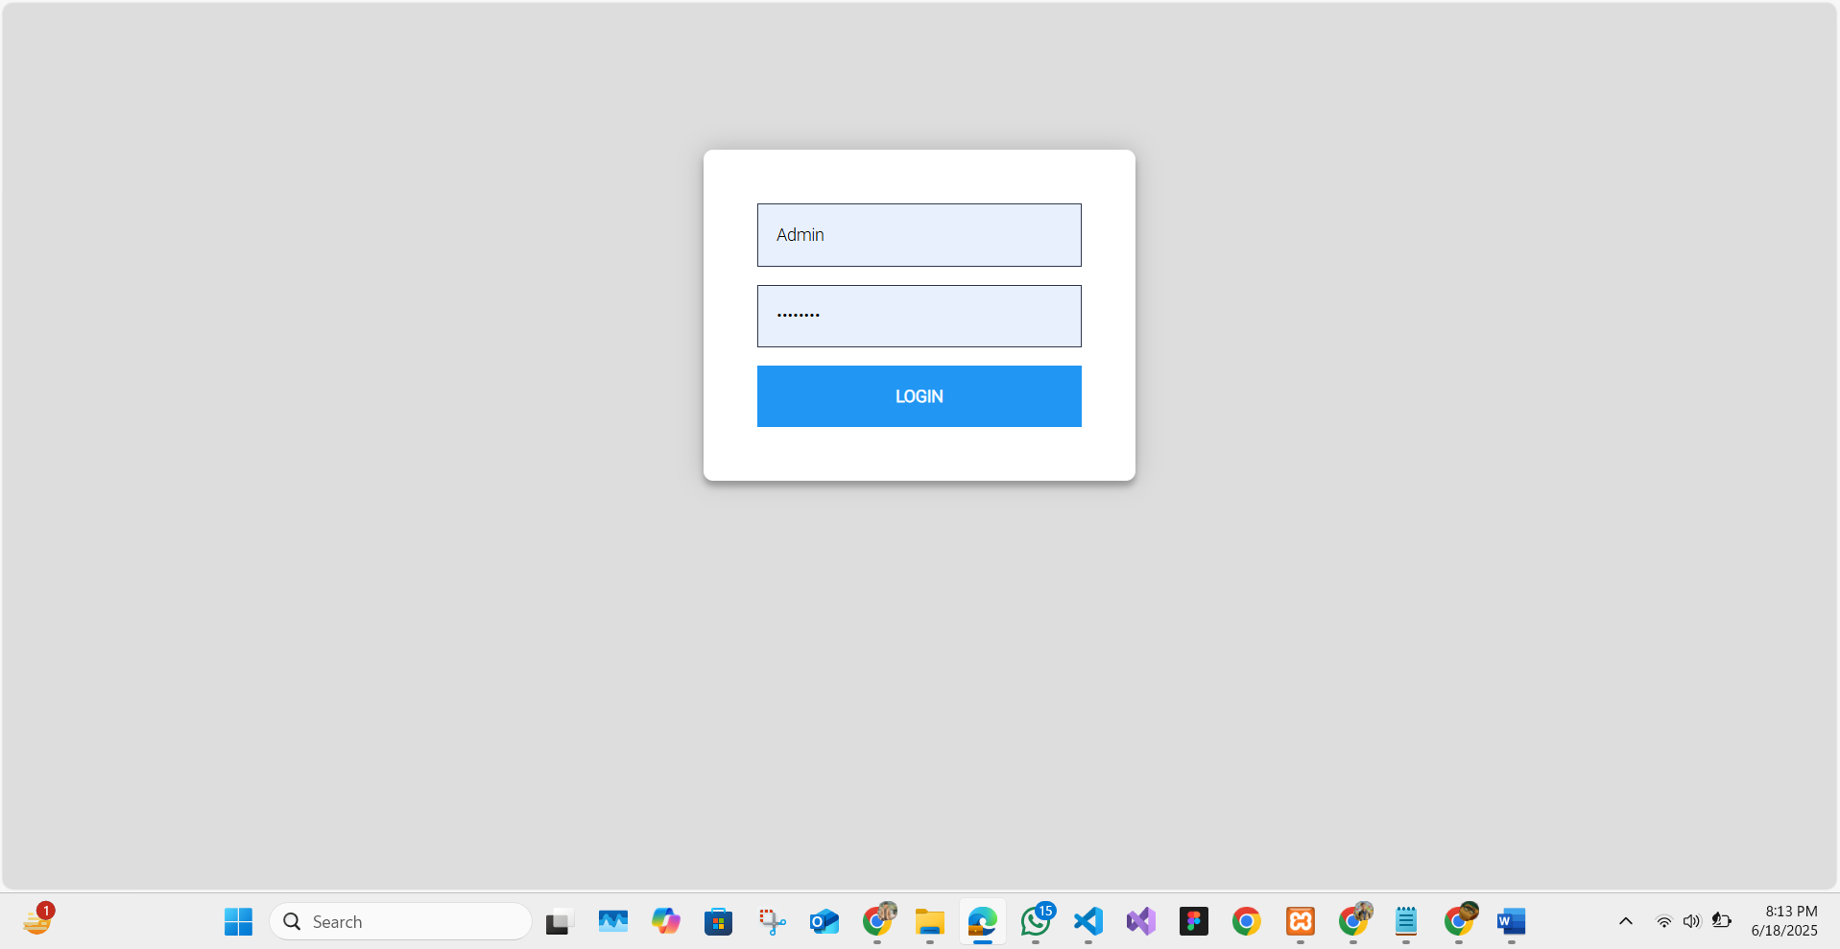
Figure 5.19 Admin Authentication Screen

- Admin Dashboard
Displays real-time platform metrics: total reviews, flagged content, new restaurant registrations, and system alerts.
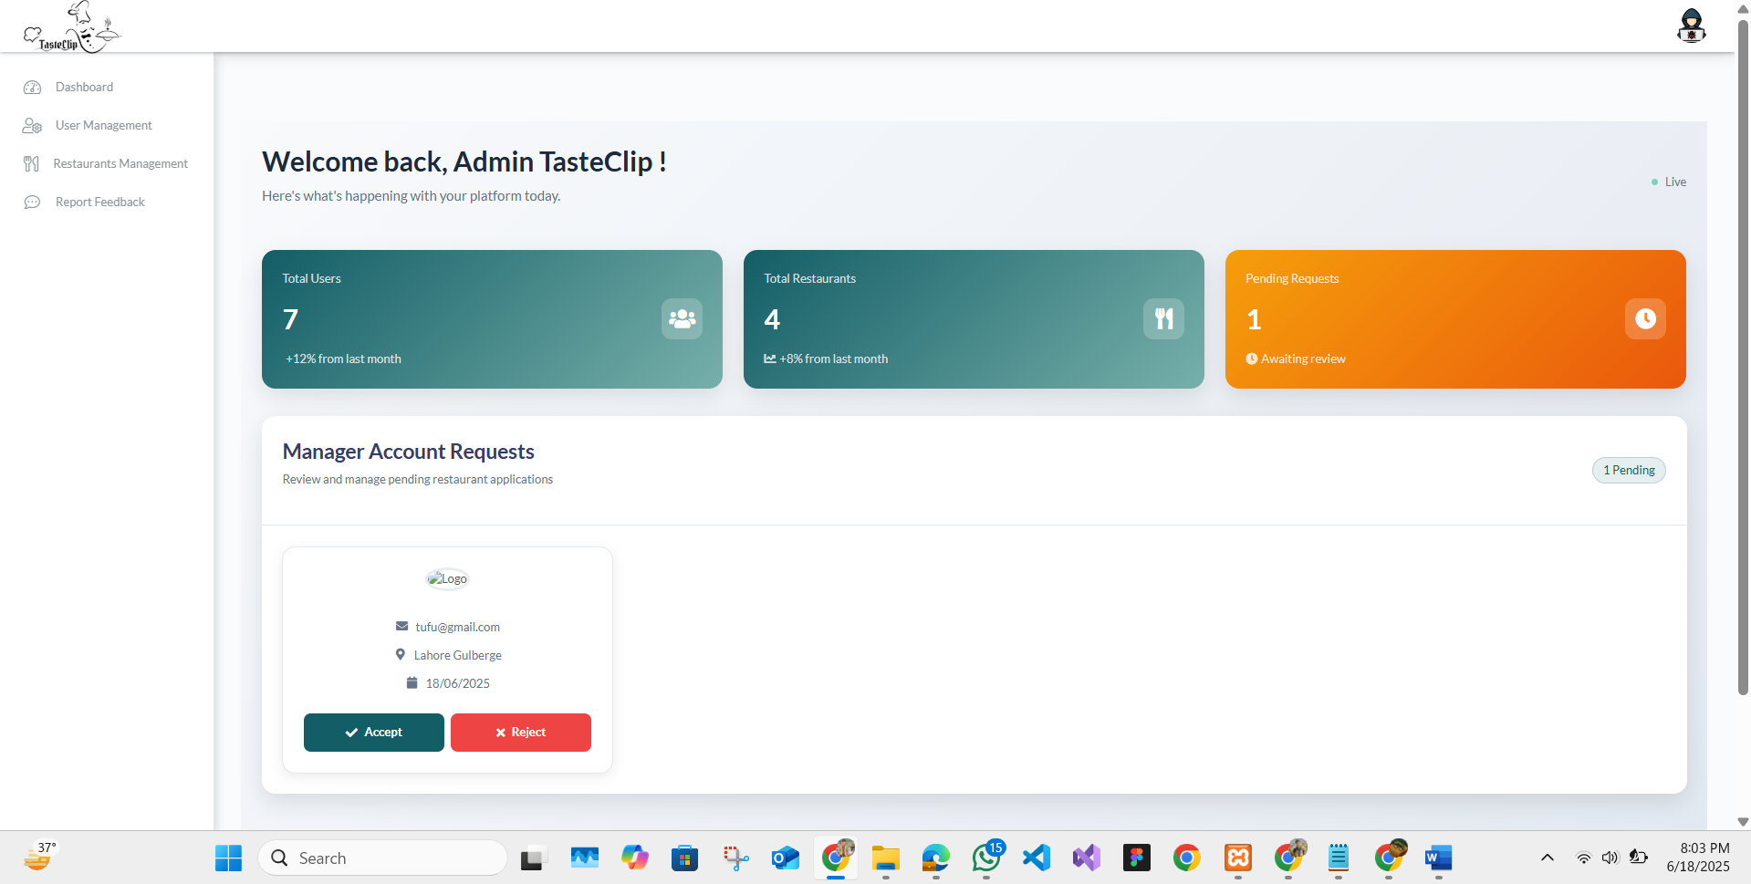
Figure 5.20 Admin Dashboard Screen
- Restaurant Management:
Enables searching, viewing, or banning users. Also supports password reset and role reassignments.
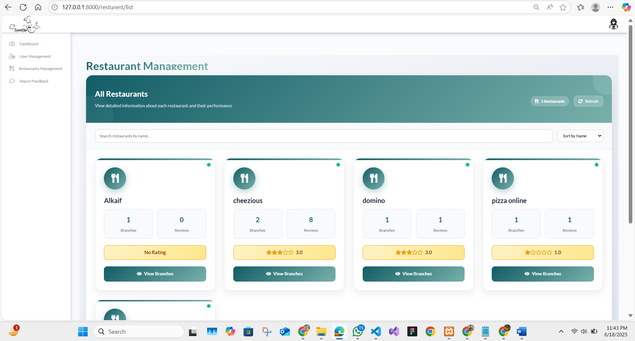
Figure 5.21 Restaurant Management Screen
- Reported Feedback Management:
Contains a queue of reported reviews. Admins can review evidence, take action, or reach out to users if needed.
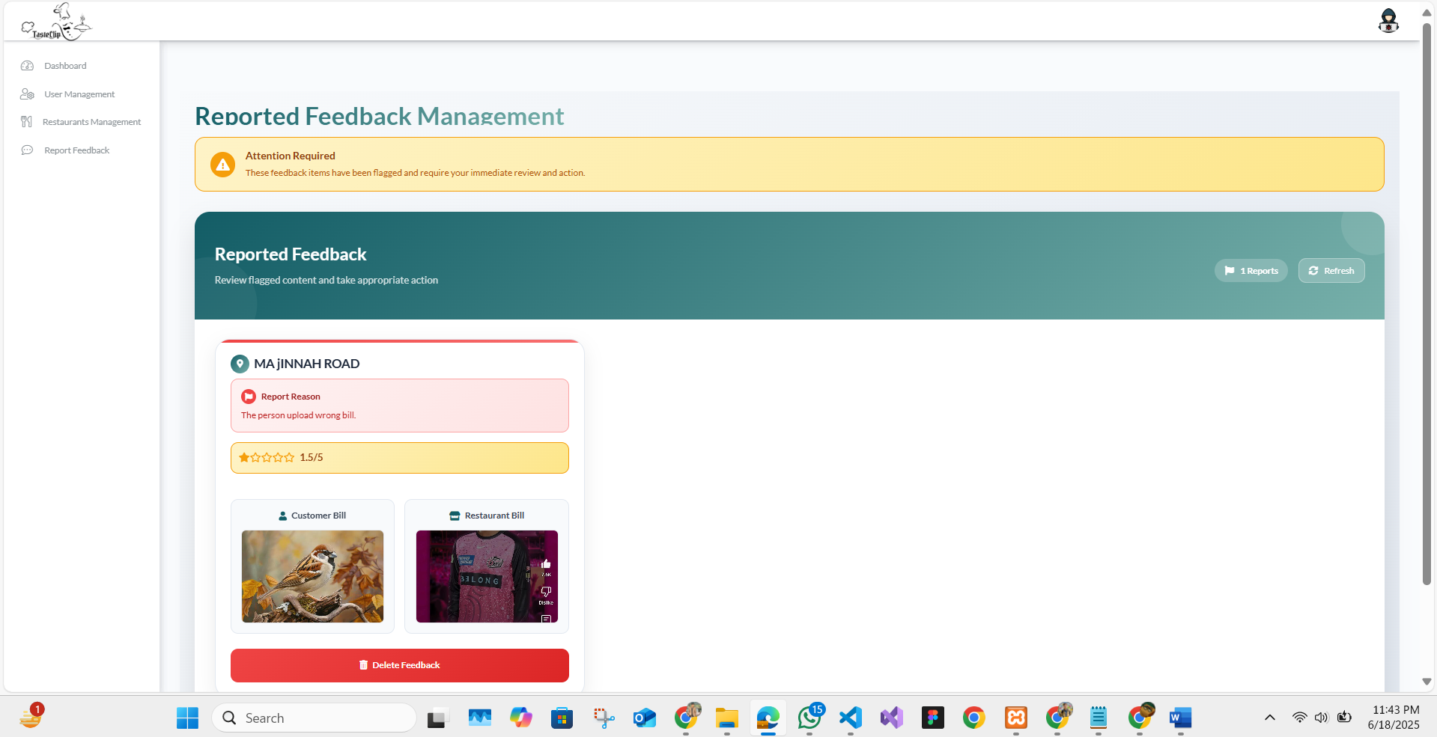
Figure 5.22 Reported Feedback Management Screen
- User Management:
Enables searching, viewing, or banning users. Also supports password reset and role reassignments.
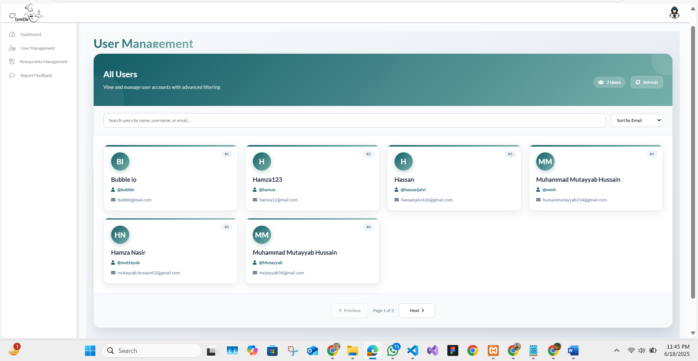
Figure 5.23 User Management Screen
- Restaurant Profile:
Provides full details of a restaurant including branches, associated reviews, events, and promotional history.
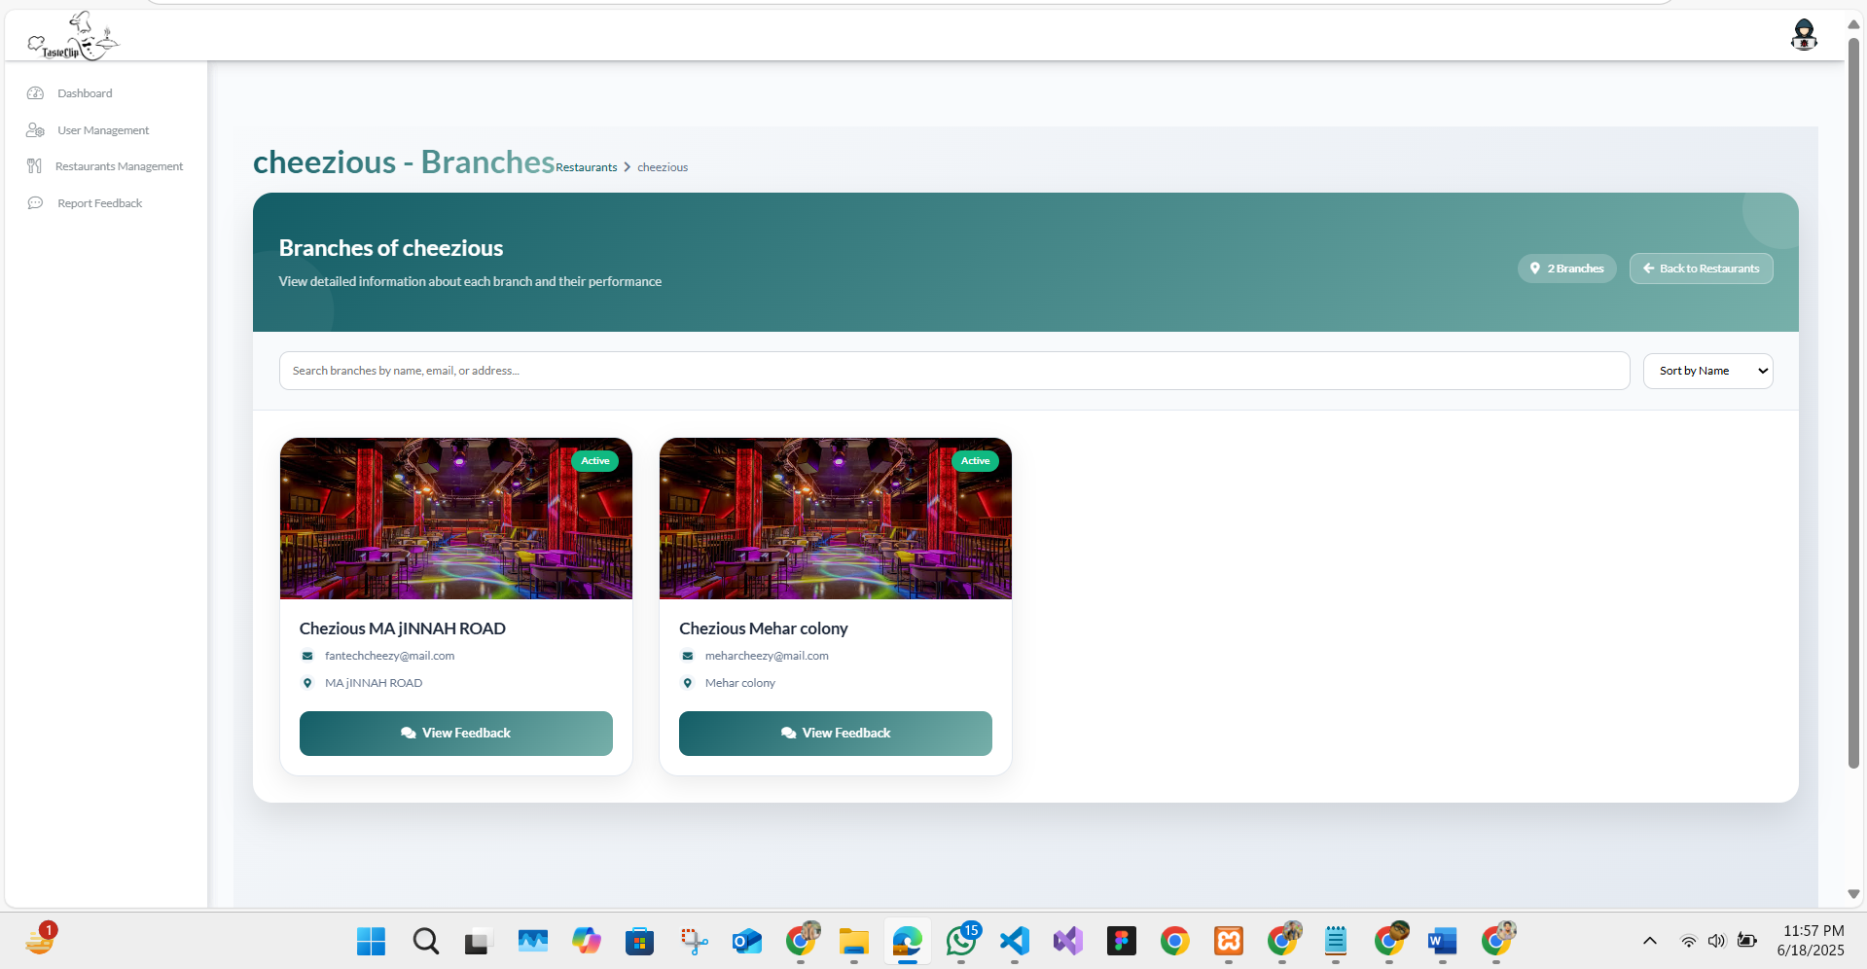
Figure 5.24 Restaurant Profile Screen

Chapter 6
Testing and Evaluation

Testing and Evaluation
The testing and evaluation phase of TasteClip, a Restaurant Review and Offer Sharing Platform ensures that the developed system meets all functional and non-functional requirements, provides a smooth user experience, and operates reliably. This chapter outlines the different types of testing performed throughout the project, including manual testing, unit testing, functional testing, integration testing, and automated testing.

Manual Testing
Manual testing was conducted to verify that the TasteClip platform behaves as expected without using automation tools. This helped validate that each component of the system works correctly and fulfills user expectations. The table below presents a summary of manual test cases and results.
Table 6.1 Manual Testing
Test Cases | Expected Result | Actual Result | Status
Customer Registration | Successful | Successful | Pass
Customer Login | Successful | Successful | Pass
Beautician/Barber  Registration | Successful | Successful | Pass
Beautician/Barber Login | Successful | Successful | Pass
Admin Login | Successful | Successful | Pass
Service Search | Accurate service  listings | Accurate service listings | Pass
Appointment Booking | Appointment scheduled successfully | Appointment scheduled successfully | Pass
Payment Processing | Payment  processed securely | Payment processed securely | Pass
Appointment Status Update | Real-time appointment  status updates | Real-time appointment status updates | Pass

Unit Testing
Unit testing focuses on verifying each independent component of the TasteClip application. Each unit (e.g., registration, login, review submission) is tested individually to ensure correctness.
Table 6.2 Unit Testing
Test Case ID | Test Case Name | Expected Result | Actual Result | Status
UT-001 | User Registration | Account created | Account created | Pass
UT-002 | Authentication | Secure login | Secure login | Pass
UT-003 | Find Best Bite | Filtered listings shown | Filtered listings shown | Pass
UT-004 | Review Upload | Review saved in DB | Review saved | Pass
UT-005 | Reward Update | Coins updated after review | Coins updated correctly | Pass
UT-006 | Event Creation | Event saved | Event saved | Pass
UT-007 | Offer Posting | Offer saved and displayed | Offer displayed | Pass
UT-008 | Admin Dashboard | Access granted to admin only | Admin access restricted properly | Pass
UT-009 | Report Review | Review flagged | Review marked as reported | Pass
UT-010 | Coin Transfer | Transfer successful | Transfer successful | Pass
UT-011 | Contact Admin | Message sent | Message sent successfully | Pass

Functional Testing
Functional testing ensures that each major function of TasteClip aligns with the business goals and user expectations.

Table 6.3 Functional Testing
Test Case ID | Test Case Name | Expected Result | Actual Result | Status
FT-001 | Home Page | Content loads successfully | Content loads successfully | Pass
FT-002 | User Login | User logs in with correct credentials | User logs in | Pass
FT-003 | Restaurant Offers | Offers listed accurately | Offers shown | Pass
FT-004 | Review Upload | Review posted with image/video | Review uploaded | Pass
FT-005 | Review Watch | Reviews load and play | Reviews displayed | Pass
FT-006 | Notification System | Notifications received | Notifications received | Pass
FT-007 | Role-Based Access | Each user accesses their module | Roles enforced correctly | Pass
FT-008 | Admin Review Approval | Admin can approve reviews | Admin approves successfully | Pass
FT-009 | Logout | Session ends securely | User logs out | Pass

Integration Testing
Integration testing validates that various components/modules of TasteClip work together and data flows correctly across the system.
Table 6.4 Integration Testing
Test Case ID | Test Case Name | Expected Result | Actual Result | Status
IT-001 | Firebase Integration | Firebase DB operations succeed | Firebase working | Pass
IT-002 | Review and Reward Sync | Coins rewarded after review | Rewards updated correctly | Pass
IT-003 | Role-Based Navigation | Users redirected properly | Navigation successful | Pass
IT-004 | Notification Delivery | Notification triggered and received | Notification received | Pass
IT-005 | Offer/Event Listing | Offers/events visible on channel | Offers/events visible | Pass
IT-006 | Responsive UI | Mobile and desktop compatibility | Layout adjusts properly | Pass
IT-007 | Admin Control | Admin actions affect system | Admin actions applied | Pass

Automated Testing
Due to the project constraints and the complexity involved in configuring automated testing frameworks for Firebase and Flutter, most testing was performed manually. While automated testing offers efficiency for large-scale applications, the TasteClip project was comprehensively validated through manual test cases, which covered all key workflows including authentication, review management, notifications, and role-based access.

Chapter 7
Conclusion and Future Work

Conclusion and Future Work

Conclusion
TasteClip is a modern restaurant review platform developed to transform how food lovers, restaurant managers, and administrators interact in the digital culinary space. The application addresses a major gap in the food-tech industry by allowing users to post dynamic, video-based reviews; a feature that significantly enhances the authenticity and engagement level of restaurant feedback, compared to traditional text reviews.

Technical Architecture:
The core objectives of the platform were achieved successfully:
- Multi-format Reviews:
Users can upload and view three types of reviews (video, photo, text), explore nearby restaurants, and benefit from coin-based rewards.
- Smart AI Recommendations:
A Find Best Bite AI feature offers smart restaurant recommendations tailored to user input.
- Interactive Review Experience:
The Review Watch screen provides a seamless TikTok-like experience for watching user-generated food content.
- Streamlined Content Upload:
The Upload Review screen enables content creation with descriptions and receipt validation.
- Restaurant Management Tools:
Restaurant managers can manage their profiles, create channels, post events and vouchers, and approve pending reviews.
- Admin Moderation Tools:
The admin dashboard supports review moderation and restaurant verification workflows.
- Secure Authentication:
Role-based access is ensured through separate authentication for users and restaurants.

Technical Architecture:
Built with Flutter and powered by Firebase, the system provides a secure, real-time, and cross-platform experience. The architecture is modular and scalable, facilitating future integration of more sophisticated features. The app’s current implementation has made food discovery more visual, interactive, and credible, while also equipping restaurants with marketing tools in the form of events and vouchers.
Despite these achievements, several advanced features remain to be implemented, offering room for continued development. These are discussed in the next section.

Scope for Further Development:
Despite these achievements, several advanced features remain to be implemented, offering room for continued innovation and system enrichment. These are discussed in the next section.

Future Work
While the ffcurrent version of TasteClip has achieved its foundational objectives, the system has considerable room for further improvement and expansion to meet evolving market demands and user expectations. Future development directions, focusing on technological enrichment, user experience enhancement, and platform scalability, are outlined below:
    - AI-Powered Restaurant Recommendations
Future iterations of TasteClip can integrate advanced Artificial Intelligence (AI) and Machine Learning (ML) algorithms to deliver hyper-personalized restaurant recommendations. By analyzing user-generated data such as dining history, liked and disliked reviews, frequently watched video content, preferred cuisines, dining budgets, geolocation patterns, and social media activity, the system can build comprehensive user profiles.
This data-driven approach will enable the platform to dynamically suggest restaurants that align closely with individual preferences and situational contexts, such as time of day or special occasions. Incorporating collaborative filtering, natural language processing, and sentiment analysis can further refine these recommendations, ensuring users discover new, trending, or hidden-gem restaurants tailored to their tastes. Such enhancements will enrich the user experience, increasing engagement duration, app stickiness, and user satisfaction.

    - Advanced Reward Mechanisms and Gamification
Expanding the reward mechanisms within TasteClip by embedding gamification strategies will further stimulate active participation and content generation. The future reward system can feature tiered loyalty programs, digital badges, leaderboards, point multipliers, and mission-based tasks.
Users can be encouraged to perform specific actions such as posting reviews, referring friends, watching content, or interacting with restaurant offers, earning virtual rewards that can be redeemed for exclusive discounts, restaurant coupons, or access to premium features. Additionally, integrating seasonal events, daily challenges, and streak rewards will create a gamified loop, fostering long-term engagement, higher retention rates, and a sense of community belonging among users.
    - Offline Video Uploading & Syncing
To enhance accessibility, TasteClip can incorporate offline functionalities that allow users to record, edit, and queue video reviews even when they lack internet connectivity. These reviews will automatically synchronize and upload to the platform once a stable connection is restored.
This feature will greatly benefit users in rural or developing areas where internet connectivity may be intermittent or costly. Furthermore, the inclusion of local device storage management and upload scheduling options can ensure efficient data usage and user convenience, removing technical barriers to content creation and encouraging participation from a more diverse user base.
    - In-App Chat and Messaging
Introducing a secure, moderated, and user-friendly in-app chat system will significantly enrich user-restaurant interaction capabilities. This messaging feature will allow users to engage directly with restaurants to inquire about reservations, event details, promotional offers, menu updates, dietary clarifications, and more.
It will also open opportunities for restaurants to proactively reach out to loyal customers with personalized messages, special deals, or event invitations. To maintain user privacy and security, the chat system should support moderation tools, spam detection, message reporting, and encryption protocols. This addition will foster a closer, more interactive dining community within the platform.
    - Expanded Admin Analytics Dashboard:
The administrative panel can be upgraded to include a more granular and visualized analytics dashboard, offering key performance indicators (KPIs) and actionable insights. Administrators will be able to monitor trends in user acquisition, video viewership, platform engagement levels, content flagging patterns, reported issues, and emerging market preferences.
Advanced visual tools such as heatmaps, real-time graphs, cohort analyses, and predictive models can support decision-making, fraud detection, content moderation prioritization, and strategic planning. This will enable admins to uphold quality assurance, user trust, and platform stability efficiently.
    - Restaurant Performance Insights:
For restaurant managers, future updates may offer comprehensive performance analytics dashboards that compile real-time data from user reviews, ratings, video comments, sentiment trends, and promotional campaign effectiveness.
This would allow managers to gain valuable insights into customer satisfaction levels, menu popularity, foot traffic patterns, and competitor benchmarking. Based on these insights, restaurants can refine their service quality, optimize marketing strategies, adjust pricing models, and improve customer retention efforts, thereby enhancing their competitive advantage within the app’s ecosystem.
    - Multi-language Support
To broaden its market reach, TasteClip can introduce multi-language and regional support, allowing users to interact with the app in their native or preferred language. Automatic language detection, AI-based translation services, and support for regional dialects can significantly improve accessibility, user comfort, and inclusivity.
This feature will open avenues to expand into international markets, foster a sense of community among diverse user groups, and ensure that restaurant promotions and events resonate culturally and linguistically with local audiences.
    - Social Media Integration
By enabling seamless integration with major social media platforms such as Facebook, Instagram, TikTok, Snapchat, WhatsApp, and Twitter, TasteClip can empower users and restaurants to share reviews, promotions, and events directly to their preferred channels.
This cross-platform exposure will extend the platform’s visibility, attract new users organically, and allow restaurants to amplify their promotional campaigns beyond the app. Moreover, embedding shareable video formats, social badges, and viral challenge functionalities can accelerate user engagement and brand awareness across multiple digital ecosystems.
    - Web-Based Application
Complementing the mobile application with a fully responsive web-based version will expand the platform's accessibility, allowing users, restaurant managers, and administrators to access TasteClip from desktop and laptop devices.
This would cater to users who prefer larger screens for video reviews, content management, or administrative tasks. The web version should offer synchronized features, ensuring consistency in user experience and data flow across devices. Additionally, the web application can serve as a powerful entry point for SEO-driven organic user acquisition through indexed content such as reviews, blogs, and restaurant profiles.
    - Geolocation-Based Promotions
Leveraging advanced geolocation services, TasteClip can introduce real-time location-aware notifications that inform users about nearby restaurant offers, live events, and trending reviews. By using device GPS data and contextual analytics, the platform can push personalized promotions when users are within proximity to specific restaurants or food districts.
Such hyperlocal marketing capabilities will drive impulse dining decisions, increase foot traffic for restaurants, and enhance the overall utility of the app as an on-the-go dining companion.

7.2.11 Augmented Reality (AR) Restaurant Previews
Incorporating Augmented Reality (AR) capabilities can offer immersive and interactive previews of restaurant interiors, menu items, seating arrangements, and live ambiance directly through the user's device camera.
Users can virtually "walk through" restaurants or view 3D models of dishes, enhancing their decision-making process before visiting. This cutting-edge feature will not only enrich the user experience but also give restaurants a futuristic marketing tool to showcase their brand identity and ambiance effectively, differentiating themselves from competitors.

References
- World Economic Forum. (2021). The Trust Deficit in Online Reviews: How widespread are fake reviews?
Retrieved from: https://www.weforum.org/agenda/2021/07/fake-reviews-e-commerce/
- Mukherjee, A., Liu, B., & Glance, N. (2012). Spotting Fake Reviewer Groups in Consumer Reviews. WWW '12.
Retrieved From: https://dl.acm.org/doi/10.1145/2187836.2187863
- The Scrum Guide™. (2020). Ken Schwaber and Jeff Sutherland.
Retrieved From: https://scrumguides.org/scrum-guide.html
- Liu, Y., et al. (2016). Understanding User Behavior in Online Feedback Systems.
Retrieved From: https://doi.org/10.1145/2858036.2858525
- Hamari, J., Koivisto, J., & Sarsa, H. (2014). Does Gamification Work? A Literature Review of Empirical Studies on Gamification.
Retrieved From: https://ieeexplore.ieee.org/document/6758978
- Luca, M. (2016). Reviews, Reputation, and Revenue: The Case of Yelp.com. Harvard Business School.
Retrieved From: https://www.hbs.edu/faculty/Pages/item.aspx?num=41233
- The Scrum Guide™. (2020). Ken Schwaber and Jeff Sutherland.
Retrieved From: https://scrumguides.org/scrum-guide.html
- Amershi, S., et al. (2019). Software Engineering for Machine Learning: A Case Study. IEEE Software.
Retrieved From: https://doi.org/10.1109/MS.2018.2882800
- Cisco Systems. (2020). Annual Internet Report (2018–2023).
Retrieved From: https://www.cisco.com/c/en/us/solutions/collateral/executive-perspectives/annual-internet-report/white-paper-c11-741490.html

